**COMPUTERIZED DAIRY FARMING MANAGEMENT SYSTEM.**

**By;**

**Wangechi Nelson Mwangi**

**HD 232-7212/2014.**

**A project documentation submitted for the study leading to a project in partial fulfilment of Bachelors’ Degree in Business Information Technology.**

**Jomo Kenyatta University of Agriculture and Technology.**

**College of Human Resources and Development.**

**Department of Business Administration.**

**Date; 14/06/ 2018.**

# 

# **DECLARATION**

This project is my original work and has not been presented for a degree in any other university.

Signature …………………… Date …………………

**Wangechi Nelson Mwangi**

**HD 232-7212/2014**

**Supervisor;**

Signature…………………………Date……………………..

Ms Ann Kaluvu

.

# **DEDICATION.**

This work I dedicate to my younger brother, my 2014 BBIT classmates group friends and my best friend Simon Dennies.

# **ACKNOWLEDGEMENT.**

I would like to acknowledge my lecturer for her guidance in development of this work. My class best friend O. D. Simon for his advice and system coding, Jkuat Liberians for internet assistance and help of books.

**Table of Contents**

**DECLARATION** ii

**DEDICATION.** iii

**ACKNOWLEDGEMENT.** iv

**Table Of Figures.** vii

**Abstract.** viii

**CHAPTER 1.** 9

**1.0 INTRODUCTION.** 9

**1.1 Background** 9

**1.2 Problem statement.** 10

**1.3 Objectives of this project.** 11

**1.3.1 General Objective.** 11

**1.3.2. Specific Objectives.** 11

**1.4** **Research Questions.** 11

**1.5 Scope.** 11

**1.6 Justification.** 12

**CHAPTER 2.** 13

**2.0 LITERATURE REVIEW.** 13

**2.1 Introduction.** 13

**2.2 Interlinking of farmer, bank, milk company and an agrovet shop as a factor of dairy business players cohesiveness in operations and hence growth.** 13

**2.3 Dairy Farmers information management and sharing.** 14

**2.4 Fast, Flexible and Accountable Mode of Transaction.** 16

**2.5 Research Gap.** 18

**2.6 Conceptual Framework.** 19

**CHAPTER 3.** 22

**3.0 METHODOLOGY** 22

**3.1 Introduction** 22

**3.2 The Targeted population.** 22

**3.3 Study Design.** 23

**3.4 System Requirements.** 25

**3.5 Sampling procedures and sample size.** 25

**3.6 Data Collection Technique and Tools:** 26

**3.7 Data Analysis** 26

**CHAPTER 4.** 27

**4.0 EXPECTED RESULTS.** 27

**4.1 Chapter Overview** 27

**4.1.1 Background information** 27

**4.1.2 Sample characteristics** 27

**4.2 Demographic profile of the respondents.** 27

**4.2.1 Age of the Respondents** 27

**4.2.2 Gender of the Respondents.** 28

**4.2.3 Highest Level of Education of the Respondents** 28

**4.2.4 Monthly Income Level (Ksh)** 28

**4.2.5 Work Status of the Respondents.** 29

**4.2.6. Duration of the respondents in the dairy farming business.** 29

**4.2.7 Perceived ease of use.** 30

**4.3 Dairy Farming Business Activities and transactions.** 31

**4.4 The Design of the System.** 32

**4.4.1 When signed in as a farmer,;** 33

**4.4.2 When signed in as Bank;** 40

**4.4.3 Signed in as KCC / Creameries.** 43

**4.4.4 Signing in as an agrovet.** 47

**CHAPTER 5.** 51

**5.0 SUMMARY OF FINDINGS, CONCLUSION AND** 51

**RECOMMENDATIONS OF FINDINGS.** 51

**5.1 Introduction.** 51

**5.2 Summary of the Findings** 51

**5.3 Conclusion.** 52

**5.4 Recommendation.** 52

APPENDICES 56

APPENDIX A: QUESTTIONNAIRE 56

APPENDIX B: COST AND MATERIAL ESTIMATES 59

# **Table Of Figures.**

Figure 1 Home page 33

Figure 2 Registration Page 34

Figure 3 Farmer Page 35

Figure 4 Message page 36

Figure 5 Agrovet products 36

Figure 6 Farmers’ interaction with the KCC. 37

Figure 7 farmers’ interaction with the bank. 37

Figure 8 Farmers’ account creation in the bank. 38

Figure 9 Farmers bank account summary. 38

Figure 10 farmers’ bank account statement viewing. 39

Figure 11 Farmer depositing in the bank. 39

Figure 12 farmer withdrawing from the bank. 40

Figure 13 Farmers’ loan request site. 41

Figure 14 Bank home page. 41

Figure 15 updates from the farmer to the bank. 42

Figure 16 farmers account in the bank. 42

Figure 17 loan request. 43

Figure 18 loan allocation to the farmer by the bank. 43

Figure 19 bank sending message to the farmer. 44

Figure 20 KCC home page. 45

Figure 21 KCC adding a new farmer. 45

Figure 22 daily post of KCC of milk delivery. 46

Figure 23 Farmers’ payment. 46

Figure 24 Farmers supply report. 47

Figure 25 daily milk rate per litre. 47

Figure 26 send message to farmers. 48

Figure 27 Agrovet home page. 49

Figure 28 Agrovet Products. 49

Figure 29 Agrovet reply. 50

Figure 30 bank paying the agrovet. 50

Figure 31 Agrovet updates o the farmer. 51

# **Abstract.**

Dairy farming remains the economic backbone of livestock farmers in high potential areas. National level production of livestock and livestock products in Kenya has increased over the years even though many households involved in livestock production have continued to be poor, unemployed and food insecure. It is perceived that poor performance of dairy farming business is stemming from poor management skills, poor platform of commerce and communication tools used. This is because there hasn’t been a better system to enable the dairy farmer to effectively manage and account for the quantity of milk sold and at which rate; the flow of the income from the sales of the milk; the resources needed by the farmer as inputs from extension services; in this case veterinary services. This propones for a development of a web based computerized dairy farming business management system, that will interlink the four main stakeholders in a dairy farming business. i.e Famer, Dairy company, Financial institution and Agrovet stores. The general objective of this project is to develop an automated dairy farming business system for managing activities in transactions carried out by the players in dairy farming business. The Specific Objectives were to create a platform that will interlink the farmer, bank, milk company and an agro-vet shop for cohesion in operations involved in the dairy business; To develop a system that will enable on time information management and sharing among the four players, and to generate a fast, flexible and accountable mode of money transaction among the dairy business players. These specific objectives still guided the questions that helped in the development of the system. The findings from the questionnaires encouraged me to develop the system since the respondents indicated very well that there is a gap in the relationship among the players which needed to be bridged for the business growth. The system is developed and tested for its functionality and is ready to be implemented. The system is aimed not only business growth and creating jobs and wealth due to increased efficiency in dairy business farming but will also help to reduce levels of poverty, increase food security and raise the economy of the nation at large.

**Terminologies;** Dairy farming, business growth, generate mode of transaction, interlink, information sharing, automate, manage activities.

# **CHAPTER 1.**

# **1.0 INTRODUCTION.**

## **1.1 Background**

The dairy sector is very important in its contribution to the economies of both the developed and the developing countries of the world. However, there are big variations in production systems and productivity between the two. In the developed countries, the production is mostly by large scale enterprises with competitive management systems and high uptake of technology and big capital outlay while in the developing countries it is largely by small scale farmers with minimum management and technical skills, limited access to capital and low access to information. This has resulted to disparities in production levels in developing and developed economies (FAO, 2010).

In Africa, Kenya is among the big producers of milk leading all the east African countries. Being a significant contribution to the national economy, household incomes and food security, the industry faces a number of technical, economic and institutional problems in milk production, processing and marketing (Karanja 2003). The informal markets control an estimated 70 percent of the total milk marketed in Kenya (KDB, 2009; Government of Kenya, 2006). These constraints affect the ability of the sector to participate and compete in the domestic and regional markets (Wambugu.S, Kirimi.L and Opiyo. J, 2011).

Milk production in Kenya is predominantly by small scale farmers, who own one to three animals, and produce about 80 percent of the milk in the country(Stella Wambugu, Lilian Kirimi and Joseph, 2011). According to the Kenya dairy master plan, over 1.8 million households are involved in milk based enterprises but in spite of this great role, the sector experiences low productivity, low profitability and slow enterprise growth (GOK, 2010). In the case of Nyandarua South District, this caused by low levels of commercialization stemming from poor business and finances management skills by the farmers and poor management extension support services.

The proposed computerized dairy farming system for Nyandarua South District is desired to increase the levels of commercialization so as to boost the dairy farming business and reduce levels of poverty, increase food security, create jobs and raise the economy of the nation at large.

## **1.2 Problem statement.**

Kenya has a vibrant dairy industry that contributes 14% of the agricultural gross domestic product (GDP), 40% of the livestock sector GDP and 4% of the national GDP. The industry is currently growing at an average rate of 5–7% per year (Corné J. Rademaker, Bockline et al.,). It provides employment to over 1.2 million citizens (KDB 2015). The country has 1.8 million milk based enterprises and is recognized in vision 2030 as an important driver of economic growth. In Nyandarua South District there is 108,384 dairy cattle (MOLD 2010), a big population relies on dairy farming business.

Although production of livestock and livestock products on average at national level has increased over the years, many households continue to lack employment due to lack of proper decision making, live in poverty due to very low income from their dairy farming business and have very little food security because the dairy farming business is not fostering the young farmers to continue in it including Nyandarua South District (GOK,2008). And though the Kenyan government over the past decade has recognized the challenges facing the dairy industry and interventions such as revival of the New Kenya Cooperative Creameries, restriction of milk powder importation and infrastructure improvement have been employed, the Nyandarua South District farmers have still not yet enjoyed the full remunerations of dairy farming.

Dairy farms have increased needs to leave traditional management systems (paper) to better direct their business using advanced computer systems (Kristensen, E., et al.. 2008). It is perceived that poor performance of dairy businesses is stemming from poor business growth caused by certain business-related factors: That’s the influence of farmers business management skills in terms of information management and sharing; the extension service providers in the mode of money transaction and the relationship among the dairy business players operating from the same platform to create cohesion among themselves for higher income (Muriuki. K. M., et al. 2014). These three factors are very significant in the dairy enterprises’ growth.

This lead me to develop a computerized system automating all the activities that are involved in each of the factors of dairy growth and conjoins all the players of dairy business together for Nyandarua South District dairy farmers and others too who are involved in the enterprise. The system will automate business management strategy processes, decrease the chances of errors, have real time communication and confidential information, help the famers account for every cent of their sales and loans in a profitable way, market milk directly to companies and reduce time wastage because it will provide a means of transactions through ordering from where the user is location.

## **1.3 Objectives of this project.**

### **1.3.1 General Objective.**

The main objective is to develop an automated dairy farming business system for managing activities in transactions carried out by the players in dairy farming business.

### **1.3.2. Specific Objectives.**

i. To create a platform that will interlink the farmer, bank, milk company and an agro-vet shop for cohesion in operations involved in the dairy business.

ii. To develop a system that will enable on time information management and sharing among the four players.

iii. To generate a fast, flexible and accountable mode of money transaction among the dairy business players.

## **1.4 Research Questions.**

i. How to create a platform that will interlink the farmer, bank, milk company and an agro-vet shop for cohesion in operations involved in the dairy business?

ii. How to develop a system that will enable on time information management and sharing among the four players?

iii. How are we going to generate a fast, flexible and. accountable mode of money transaction among the dairy business players?

## **1.5 Scope.**

The dairy sector is very important in its contribution to the economies of both the developed and the developing countries of the world. Also, dairy industry is a major employer in the world and it is growing further as the demand for milk is increasing with the growth in population to over the 7 billion mark. It has also become one of the biggest support sectors in our country and in specific in Nyandarua South District for livelihood earning and economy at large. To experience maximum profit from dairy farming business to those who have ventured into it, there is a need to leave traditional ways of managing business, flow of information, networking of stakeholders in the business and also ways of marketing and embrace new technology of computer systems. The automated dairy farming system will help in communication, decision making, management and storage of all business plans for higher returns and solve other farmers related problems. The scope of this work is to build an application that suits the dairy farming business needs for Nyandarua South District region.

## **1.6 Justification.**

Kenya’s dairy industry is one of the most impressive in the developing world. Among the major millennium development goals of the Kenyan government is creating jobs, poverty reduction and food security. Dairy farming stands a better platform as compared with other sectors of agriculture in this nation as far as marketing of the product is concerned. The country has the most competitive processing sector in the region with an excess capacity and the Smallholder dairy farmers are well-placed to produce for this capacity if the conditions are right (Karanja, 2003). If all region of this country would produce the same with dairy farmers taking dairy farming with the seriousness that it deserve, then unemployment will reduce among many youth who are complaining daily of lack of jobs, improve livelihood among dairy farmers and boosting our economy as a country as well as reducing poverty among many But in order to reach the millennium development goal of this nation, the dairy farming business processes must be upgraded to suit times and change of operations to the current technology so as to equip the farmer with the right business management system and tools so as he/she can realize the benefits of dairy business.

# **CHAPTER 2.**

# **2.0 LITERATURE REVIEW.**

## **2.1 Introduction.**

The purpose of starting any business venture is to create wealth. This is achieved through enterprise growth and development. This growth may be reflected in terms of profitability, revenue turn over, market share, customer base, business networks, capital base, size of enterprise and number of employees. After reviewing available reports in the livestock production office in Ministry of Livestock Development (MoLD), shows that most dairy enterprises seem to have stagnated in their growth over the years. The production per cow per day is estimated at 8 liters (MOLD, 2011) with a profit margin of KES 12.30 per liter in the lower highlands (Mburu L.M, et al., 2007). This is not enough revenue to sustain and grow the business and therefore the question as to how to improve growth of dairy enterprises by increasing productivity and size of business therefore persists. Preliminary investigations show that dairy business management skills and extension service support services i.e financial support institutions and agrovet stores have significant roles in the dairy business growth and development.

## **2.2 Interlinking of farmer, bank, milk company and an agrovet shop as a factor of dairy business players cohesiveness in operations and hence growth.**

Interconnection involves information and communication technologies in private data exchange between businesses. A more detailed definition of Interconnection is the deployment of IT traffic exchange points that integrate direct, private connections between counterparties. Interconnection is best achieved hosted in carrier-neutral data center campuses, where distributed IT components are collocated. In an age when reams of information race around the world with the click of a finger and massive transactions routinely occur several times faster than the blink of an eye (Jim Poole, 2017). Now, strengthening of national agricultural support system has been advocated as a strategy for increasing agricultural production in Sub-Saharan Africa by governments in the region and by international development agencies (Evenson and Mwabu, 2008). In addition, investments in information and communication technologies have significantly improved the efficiency of agribusiness marketing systems in Africa (Haggblade, 2011). In turn, improved information flows lead to decreased price variability, lower risk premiums and hence lower marketing costs, timely communication and decision making are enhanced since there is resources to depend on.

Agricultural sector Information technology services plays a vital role in the sharing of knowledge, technologies, agricultural information and linking the farmer to other actors in the economy. The networking services enhanced by Information technology is, therefore, one of the critical change agents required in the transformation of subsistence farming to modern and commercial agriculture, which is critically important in promoting household food security, improving incomes and reducing poverty (GOK, 2009).

A consensus exists that networking services, if functioning effectively, improve agricultural productivity through providing farmers with finances and information that helps them to optimize their use of limited resources. Variations in management practices and husbandry skills among small farmers in Kenya are very wide. Achieving gains in agricultural production efficiency depends on many factors, but interlinking is likely to be among the most important (Muyanga and Jayne, 2006).

Interconnection plays a role in dairy enterprise growth through provision of financial support by providing adequate loans, helping in financial management, information dissemination, creating linkages with markets and service providers, and interactions with farmers to change negative attitudes and perceptions. This calls for a positive close relationship between the other parties involved in dairy business and the dairy farmer in an environment of mutual trust. The declining effectiveness of the public networking among the key players in this business of dairy farming has been identified as one among the factors impeding agricultural growth in Kenya (Muyanga and Jayne, 2006). Therefore, in this work, networking of dairy business stakeholders is viewed as one that influences growth of dairy businesses in terms of productivity, profitability and size of enterprise.

## **2.3 Dairy Farmers information management and sharing.**

Surveys of Ministry of Livestock Development have shown that many dairy farmers operate without a business plan, under poor communication, with lack and lose of information and information brake down and operate on a trial and error basis. Many dairy farmers do not receive and disseminate information on time and also do not keep farm records and those who do have very scanty records (MoLD, 2011). The absence of such vital business information communication on time and documents, significantly affects the decision-making process as decisions are left to instinct and not based on sound business management principles. Management experts indicated that distinctive management abilities and practices on a similar kind of enterprise of dairy farming and similar production frameworks have diverse financial success (Ford and Shonkwiler, 2004). Management does are described into various functions which incorporate production management, management of finance and human resource management (Gloy, 2003). Management of finances is considered to mainly deal on how farms gain funds and oversee them to the fulfillment of farmers objectives (Gloy, 2003). Different works dwell on determining the connections amongst profitability and leverage, while other consider renting practices of book keeping (Gloy, et al,. 2002).

Farmers business information management and sharing skills are known to give information on the performance of a business by keeping track on how the business is performing with respect to liquidity, advantage and efficiency being utilized of favorable assets and capital (Gary and Jenny, 2008). Moreover they help the farmer to discover the performance of the farm in respect of the different aspects. These may comprise of investment for assets versus profitability, cost of operation and the wages that the farmer gets (Western Dairy Org. Meeting, 2009). Other indispensable funds measure that farmers require are the liquidity measures, profitability measures, fund efficiency and repayment capacity. This may cause challenges in the local smallholder sector because the farmer is not keeping adequate records. This can be a useful tool for he farmer to make critical choices by knowing whether his business is doing great or something else which should be made possible by benchmarking with a different player in a similar industry (Western Dairy Org. Meeting, 2009). A farmer is esteemed to be financially effective if his business creates profits and enhances its real total assets position. Furthermore, keeping up a sound operations and expenditure track is considered as a financial success factor as well (Kaase, 2003). Now, the extension agents who are in contact with the farmers are ill equipped to offer quality business advisory services and stick to technical packages where they are conversant. This is suspected to be one of the reasons for poor performance of the dairy enterprises resulting to poor growth.

One of the key areas in business management is strategic management. Strategy entails the deployment of resources to achieve optimal organizational aims and objectives. This includes marshalling the firm’s internal resources to meet the demands, challenges and the external operating environment in pursuit of its objectives (O’Regan and Ghobadian, 2004). In this work, business plans, marketing plans and budgets will be taken as part of strategic planning and their influence on growth establishment. The goals of any firm once they have been defined become the basis for planning and future development. Management planning and monitoring are crucial factors in guaranteeing the correct development course of a business as well as generating profits. Strategy is a key factor for the competitiveness and profitability of a company. Success in strategy implementation depends on the internal factors, such as the way the owner/manager makes decisions in the current environment and the human resource capacity as well as external variables. This work sought to establish the management strategies used by dairy farmers in managing their enterprises and the influence of such strategies or lack of them on productivity and profitability.

In Kenya’s smallholder dairy sector, the appropriate combination of improved cattle breeds, artificial insemination services, specially formulated livestock feeds and improved veterinary services nearly quadruple milk production per cow (Ngigi et al., 2010) as cited in (Haggblade, 2011).This raises the question whether the real issues influencing productivity and profitability could be business management related and whether the dairy farmers have adequate business management skills to drive growth of their enterprises.

## **2.4 Fast, Flexible and Accountable Mode of Transaction.**

The term “e-Business” has a very broad application and means different things to different people. Furthermore, its relation with e-commerce is at the source of many disagreements. (Melao, 2008). A more comprehensive definition of e-business is: “The transformation of an organization’s processes to deliver additional customer value through the application of technologies, philosophies and computing paradigm of the new economy.” In a simple sense, E-Business can be defined as, “the organized effort of individuals to produce and sell, for profit, products and services that satisfy society’s needs through the facilities available on the Internet” (Brahm Canzer, 2009). However, (Melao, 2008) suggests that it was only in the 1990s, primarily via the Internet, that e-Business has emerged as a core feature of many organizations. In his opinion, the hope was that e-Business would revolutionize the ways in which organizations interact with customers, employees, suppliers and partners. Some saw e- Business as part of a recipe to stay competitive in the global economy. Some authors view e-Business as the evolution of e- commerce from the buying and selling over the Internet, and argue that the former is a subset of the latter.( Turban et al., 2006). Others defend that, although related, they are distinct concepts (Laudon and Traver, 2008). More precisely they assume that “e-business is not just about e-commerce transactions or about buying and selling over the Web; it is the overall strategy of redefining old business models, with the aid of technology, to maximize customer value and profits”. Kalakota and Robinson’s definition is of great importance because it describes e- 6 business as an essential business-reengineering factor that can promote company’s growth.

According to (Melao, 2008) the clear commonalities among these definitions, include the improvement of business processes and the use of ICT in intranets, extranets and the Internet to conduct business. He defines e-Business as the use of ICT as an enabler to (re)design, manage, execute, improve and control business processes both within and between organizations. Thus, front and back-office integration and multi-channel integration become crucial in e-Business, which requires a challenging process improvement approach to support the necessary organizational, technological and social changes. The article published by Rahmath Safeena, Hema Date and Abdullah Kammani in January 2001, states that, the various areas where the banks are preparing to use e-business approach include familiar and relatively mature electronically based products in developing markets, such as telephone banking, mobile banking, credit cards, ATMs, and direct deposit. This means that most of the banks have recognized the need to change their business process to conform to changing business trends in order to keep up with competition.

Electronic business methods enable companies to link their internal and external data processing systems more efficiently and flexibly, to work more closely with suppliers and partners, and to better satisfy the needs and expectations of their customers. EBusiness refers to more strategic focus with an emphasis on the functions that occur using electronic capabilities. (Yen-Yi, 2006). Electronic business can be approached in many different ways, depending on the specific business process that might be carried out through the Internet. Thus, several Internet usage profiles or approaches are possible. A company must determine which 8 profile or combination of profiles best suits its particular business context and strategy (Mendo and Fitzgerald, 2005). According to Basu and Muylle (2007), companies can gain two fundamental types of benefits from e-Business. These are generally described as: Value Creation or Value Enhancement for one or more of a company’s stakeholder groups; and Lower Cost of providing goods and services to the market place. Examples under Value Creation include Improvement in internal and external communication through effective e-marketing, increment of sales through an e-commerce website integrated with a back-office systems and Improvement in supplier relations and productivity through collaborative workspaces (Basu and Muylle, 2007). And examples under Lower cost are: reduction in communication and travel costs using online meeting tools; shared workspaces and; benefit from license free open source alternatives to proprietary software.

Businesses also see tremendous opportunities for cost saving, revenue generation, increased market share, marketing and market access, and improving customer service through direct links that facilitate speedy enquiry and feedback. Similarly, consumers can inter alia, access the world market through the virtual economy on the Internet, choose from a wider variety of products, and shop in the comfort of their homes. Globalization and specifically liberalization of communication networks have all facilitated this break-through that further presents a massive boost for international trade (A. K. Sohani, 2009). However, many writers of e-Business and e-commerce extol the enormous potential and opportunities provided for consumers and businesses globally. However there are some drawbacks and the benefits to be derived tend to be overstated. Many managers and investors are facing strong pressure to answer the question of whether and how ebusiness investments create business value, because it is not clear to them how this value is created, and what are the factors that shape that value, also which of them are most important (Alawneh A., and Hattab E 2009).

## **2.5 Research Gap.**

Dairy farming fills the funding gap created by the inadequacies of the financial markets and low acceptance of insurance policies in most developing countries as it ensures regular cash flows to the farmers as opposed to intermittent incomes from crop cultivation and other forms of livestock keeping (FAO, 2011,Omole et al 2004). In Kenya dairy farming accounts for about four percent of the country’s Gross Domestic Product (GDP) and fourteen percent of total value of agricultural output (KNBS, 2009). About eighty percent of the dairy output in Kenya emanates from small holders, many of whom are situated in the central highlands (Smallholder Dairy Project, 2008). And though the Kenyan government over the past decade has recognized the challenges facing the dairy industry and interventions such as revival of the New Kenya Cooperative Creameries, restriction of milk powder importation and infrastructure improvement have been employed; the emergence of technology and internet and the development of online transactions creating e-commerce and e-business; the Nyandarua South District farmers have still not yet enjoyed the full remunerations of dairy farming business.

I perceived this is because farmers are still using the manual ways of information handling and communication with less or no data storage, poor networking and interconnection of operations among the stakeholders leading to non-cohesiveness of dairy business operations among the players; and though many other businesses have embraced the use of internet in money and other resources transactions, it has not yet been implemented in the dairy farming business. You will find that farmers still trek or travel to bank, milk companies and agro-vets shops to gather information, give orders or make transactions.

## **2.6 Conceptual Framework.**

Smallholder dairy farmers have different management skills and characteristics which includes farmers education, training age and experience in the dairy business. Also the use of different financial management practices, transaction modes, information sharing, financial records keeping and smooth operations flow for them to earn profits. Therefore farmers are faced with institutional environment which includes issues like the interconnectivity among the farmer himself with the bank as a financial institution, Milk Company being the market and an agro-vet shop as an extension service. Also they are faced with the issue of on time information sharing and storage of that information for future decision making and finally the issue of fast, flexible and accountable mode of money/resource transaction. When this is put in place, the business is going to grow and the stakeholders are especially the farmer is going to have more profits, have increased productivity hence the size of the business will expand and communication and information sharing is going to be enhanced leading to cohesion of operations among the stakeholders and resources transaction will be effective.

Dependable variables. Independent variables

|  |
| --- |
| * Interconnect the farmer, bank, kcc and agrovet. * Enhanced on time communication and information sharing among the stakeholders. * Generate a fast, flexible and accountable mode of transaction among the stakeholders. |

|  |
| --- |
| Dairy farming business growth which will be characterized by;   * more profits to the farmer, * cohesiveness of operations, * increased productivity, * expansion of the business, * increased food security, * job employment, * enhanced communication and information sharing and also * enhanced resources sharing among the stakeholders. |

|  |
| --- |
| Government policy and regulations, Infrastructure development and state of the economy. |

In conclusion, because farmers are still using the manual ways of information handling and communication with less or no data storage, poor networking and interconnection of operations among the stakeholders leading to non-cohesiveness of dairy business operations among the players; and though many other businesses have embraced the use of internet in money and other resources transactions, it has not yet been implemented in the dairy farming business. You will find that farmers still trek or travel to bank, milk companies and agro-vets shops to gather information, give orders or make transactions; I have proposed to develop a computerized dairy farming management system that will interconnect the four players of the dairy business, cater for the need for on time communication and generate a fast, flexible and accountable mode of resource and money transaction in the dairy business players which will lead to dairy farming business growth which will be characterized by; more profits to the farmer, cohesiveness of operations, increased productivity, expansion of the business, increased food security, job employment, enhanced communication and information sharing and also enhanced resources sharing among the stakeholders. It is to be noted that the government policy and regulations, Infrastructure development and state of the economy must be constant for the benefits of the business.

# **CHAPTER 3.**

# **3.0 METHODOLOGY**

## **3.1 Introduction**

This chapter identifies the research design of the study. It further highlights the target population, study designs, system requirements’, sampling procedures and sample size, data collection techniques and tools and how the data collected is going to be analysed. Previous studies have employed a variety of methods to deal with the inherent problems involved in the study, profitability and growth of dairy farming business, particularly dairy farming management skills and extension service providers relationship with the famer. The most methodologically complex and time-intensive studies have chosen to rely solely on the scientific method, and subsequently attempted to control for selection bias by using large data sets with carefully constructed control groups, and advanced econometric techniques. In this work, descriptive survey design will be employed. A descriptive survey determines and reports the status of events or phenomenon without manipulation (Mugenda & Mugenda, 2008).This study will collect data, analyze it and make generalizations on the influence of the selected factors, that is; a platform that will interlink the farmer, bank, milk company and an agro-vet shop for cohesion in operations involved in the dairy business; a system that will enable on time information management and sharing among the four players; and a fast, flexible and accountable mode of money transaction among the dairy business players as a business growth and profitability increase factors.

## **3.2 The Targeted population.**

The target population of this study will be all dairy farmers marketing milk through dairy companies such as Kenya Co-operative Creameries and Brookside in Nyandarua South district. There are 5 major such groups in the district and a small part of the whole population marketing their milk will be selected from the members of these groups and be taken as the sample of the target population. The choice of milk marketing groups is necessitated by the fact that farmers marketing their milk formally are more likely to view their farming as a business enterprise. It is also to be noted that farmers take their milk at collection points where the creameries vehicles come picking up the milk from.

## **3.3 Study Design.**

This study attempts to find a middle ground between the subjective and completely qualitative studies, and the econometrically rigorous and methodologically sound, but expensive and time-consuming quantitative studies. Each approach offers certain advantages and disadvantages. A sample survey and the attendant statistical approaches offer representativeness, quantification, and attribution, while the humanities approach grants the reader the ability to uncover processes and to capture the diversity of perceptions, views of minorities, unexpected impacts, etc.. This study seeks to combine these unique advantages by using a composite of the two methods. The quantitative aspect of the study focuses on a small-scale sample survey of current KCC members and a control group of incoming members. The results from the survey are then crosschecked using information gathered from focus group discussions and interviews with key informants. Impacts are assessed at both the individual and the household level, primarily using the data gathered from the questionnaire. As it is very difficult to measure community-level impacts in a quantitative survey without the use of a control group of eligible non-members, impacts at the community level are addressed briefly, based primarily on information gathered through focus group discussions. The study is to capture externalities that will create a web-based computerized dairy business management system that will interlink the farmer, bank, cremeries and agro-vet shop; also provide on time information management and sharing and generate a fast,f lexible and accountable mode of resources transaction among the players so as to; increase productivity, raise profitability, improve information network and expand the size of the market which will help in reducing the levels of poverty, increase food security and open investment opportunities there by creating jobs.

(a) To create a platform that will interlink the farmer, bank, milk company and an agro-vet shop for cohesion in operations involved in the dairy business. In the home page one will have the privilege of interacting with the system by;

(b) To develop a system that will enable on time information management and sharing among the four players.

(c) To generate a fast, flexible and accountable mode of money transaction among the dairy business players.

The system must be installed by all the four players from their ends and register as per their role so as to be connected so that they will be able to operate from the same platform. The registration will require; first-name, second-name, username, password and verification of the password, you choose your role i.e either a farmer, bank, kcc or agrovet and the telephone number. After installation and registering as per the role of the player, you sign in using the username and the password chosen. The system also gives one privilege to change the password, avatar and log out from it.

**Signed as a farmer;**

When signed in as a farmer you;

Get the daily report from the creameries of the quantity of milk you have sold and also , at what rates. Also the system will give the farmer the privilege to send a message to the creamery and also receive new information from the creamery on time.

A famer also gets to interact with the bank where by he can;

Open an account, view the account summary, get the account statement, do deposits and withdrawals and also can request a loan from the bank.

The farmer also can interact with the agrovet shop and will be able to;

View their products and also place and order to be supplied with resources that the farmer wants by just, sending a message and can also, receive immediate feedback from the agrovet shop.

**Signed as bank;**

When signed as bank, it will be able to see the;

Updates which the farmers messages are, See the farmers account, loan requests, loans allocated and can give an, immediate feedback to the farmer.

**Signed in as KCC;**

When signed in as kcc, the creamery will be able to;

Add new farmer as their customer, post the amount delivered per farmer, pay the farmers milk to the bank, post daily reports so that the farmers can be able to access them, and also give the updates of daily sales rates. The creamery will also be able to give immediate feedback to the farmer.

**Signed in as agrovet;**

When the agrovet signs in, they will be able to;

Post their products so that the farmer can see what is in the market, send feedback message back to farmer, will also be able to interact with the bank for payments made by the farmer to the agrovet and also will be able to update the farmer on new developments.

## **3.4 System Requirements.**

This are both the software and hardware requirements so that the system can function properly. The proposed are the minimum requirements on the server side and on the client side. On the server side:- what is needed for the hardware is a 1.60GHz Processor. 512 MB RAM and a hand disk of 40GB.

For the software is:- PHP 5.4.16 on the front end,; My SQL 5.6.12 on the back end; windows XP any compatible OS and an Apache 2.4.4 for the wed server.

On the client side:- hardware requirements are:- 1.60GHz Processor. 512 MB RAM and a hand disk of 40GB.

For the software:- we need windows XP or any compatible operating System and internet explorer or any compatible browser for the browser.

## **3.5 Sampling procedures and sample size.**

The sampling technique to be employed in this study will be the stratified proportionate random sampling. The following formula provided by (Kothari,2004) will be used to calculate the sample size for the study:

n = Z2.p.q.N / e2 (N-1) +Z2p.q

Where N= total population

n= sample size

Z = scope

e= error =0.05

The sample size will include selected company staffs, bank staffs, Agro-vet stores staffs and the dairy farmer.

## **3.6 Data Collection Technique and Tools:**

The study will involve quantitative and qualitative components. This study will employ the use of both primary and secondary data. Questionnaires, personal interviews and observation will be used to collect data. The questionnaires will consist of both closed and open-ended questions. The questionnaire will have 1 sections ; one dealing with general information on the participants, and the ease of use of the proposed system. The questionnaire is going to be presented in the form of statement of a 1 to 5Likert scale for respondents to score statements of dairy farming performance.

## **3.7 Data Analysis**

Data will be analyzed using descriptive statistics. First step in the analysis will be to classify and tabulate the information collected. The questionnaires will be edited to ensure completeness and consistency. Coding of data will be done to convert responses into measurement that could be statistically analyzed. Descriptive statistics will be used to describe data collected from the research. This will include the mean and standard deviation. Measures of central tendency will be used to determine the mean score from the group of scores in the study. The mean will then be used to draw conclusion. Measures of variability will be also computed to show variance within population and this will be done using standard deviation. Frequencies and percentages will be used to describe and summarize the data.

# **CHAPTER 4.**

# **4.0 EXPECTED RESULTS.**

## **4.1 Chapter Overview**

This chapter analyses the responses and represents the research findings from the data collected from the survey. The data collected is ordinal, quantitative and numerical, thus data analysis is based on a quantitative method. The outputs are generated using the SPSS package. A 5-point Likert scale is used to measure the output of each item answered by the participants.

### **4.1.1 Background information**

This section provides background information for the survey questionnaires.

### **4.1.2 Sample characteristics**

Questionnaires were distributed to the stakeholders of dairy farming business who were from the selected areas in Nyandarua South district. I managed to collect data from 300 respondents representing a response rate of 75.19%.

## **4.2 Demographic profile of the respondents.**

### **4.2.1 Age of the Respondents**

From the findings of the study, 81.7% of the respondents were aged 18 years to 39 years as shown in table 1 below while 18.3% of the respondents were above 40 years old.

Table 1(a): Age of the respondents.

|  |  |  |
| --- | --- | --- |
| Age (years) | Frequency | Percent(%) |
| Between 18 and 29  Between 30 and 39  Between 40 and 49  Between 50 and 59  Above 59 | 167  78  42  12  1 | 55.7  26.0  14.0  4.0  3 |
| Total | 300 | 100.0 |

### **4.2.2 Gender of the Respondents.**

Majority of the respondents were male at 58% while female were 42%.

Table 1 (b): Gender of the Respondents.

|  |  |  |
| --- | --- | --- |
| Gender | Frequency | Percentage (%) |
| Male  Female | 174  126 | 58.0  42.0 |
| Total | **300** | **100** |

**4.2.3 Highest Level of Education of the Respondents.**

Majority of the respondents (45.7%) had undergraduate academics qualification.

Table 1(c): Highest Level of education of the Respondents.

|  |  |  |
| --- | --- | --- |
| Education Level | Frequency | Percent (%) |
| Secondary  Certificate  Diploma  Undergraduate Degree  Postgraduate Degree  Other | 24  22  44  137  72  1 | 8.0  7.3  14.7  45.7  24.0  3 |
| Total | **300** | **100** |

### **4.2.4 Monthly Income Level (Ksh)**

From table the table below, it is clear that 40.3% of the respondents earn between Ksh 20,000 and ksh 40,000. The least number of the respondents earn above ksh 80,000.

Table 1(d): Monthly income Level of the Respondents.

|  |  |  |
| --- | --- | --- |
| Income Level (ksh) | Frequency | Percent(%) |
| Below 20,000  Between 20,000 and 40,000  Between 41,000 and 60,000  Between 61,000 and 80,000  Above 80,000 | 103  121  42  25  9 | 34.3%  40.3%  14%  8.3%  3% |
| Total | **300** | **100** |

### **4.2.5 Work Status of the Respondents.**

From the table 1(e) below, majority are farmers with 86.7%.

Table 1(e): Work Status of the Respondents.

|  |  |  |
| --- | --- | --- |
| Work Status | Frequency | Percent(%) |
| Bank  Creameries  Agrovets  Farmers | **3**  **5**  **32**  **260** | **1**  **1.7**  **10.7**  **86.7** |
| Total | **300** | **100** |

### **4.2.6. Duration of the respondents in the dairy farming business.**

The data on the duration of respondents being a business person in one area or another shows that majority of the respondents have been in dairy farming business for more than 2 years.

Table 1(f): Duration of the Respondents in dairy farming buisness.

|  |  |  |
| --- | --- | --- |
| Duration | Frequency | Percent (%) |
| Below 6 months  Up to 1 year  Up to 1 and half years  Up to 2 years | 21  43  80  156 | 7  14.3  26.7  52 |
| Total | **300** | **100** |

### **4.2.7 Perceived ease of use.**

A five likert scale where 1=STRONGLY DISAGREE (SD), 2=DISAGREE (D), 3=NOT SURE (NS), 4= AGREE (A), AND 5=STRONGLY AGREE (SA); was used to measure the respondents statement concerning perceived ease of use of e-chama system use in table 4.1.

Table 4.1 Perceived ease of use.

|  |  |  |  |  |  |
| --- | --- | --- | --- | --- | --- |
| Item | Statement | Mean | Median | Mode | Std. dev |
| i. | Learning to use the system would be easy | 3.96 | 4.00 | 4 | .806 |
| ii. | Interacting with the system won’t require a lot of mental effort | 3.72 | 4.00 | 4 | .992 |
| iii. | It will be easy to use system to accomplish my tasks | 4.00 | 4.00 | 4 | .890 |
| iv. | Using system does not require training | 3.11 | 3.00 | 4 | 1.266 |

## **4.3 Dairy Farming Business Activities and transactions.**

About 98% of respondents (294 out of 300 respondents) are in the dairy farming business majority being the farmers and aged 18 to 39 which is the most productive age in a countries economy also is the most learned age bracket in the population. Most of the respondents have an experience dairy farming business either from their counterparts for more than two years. Therefore this indicates that the highest number population and homes are depending on this business for their dairy living and wealth creation.

The most fundamental ideology in the dairy farming business is the relationship among the four main players and the involvement of each player. The players are the farmer, the bank which is the financial institution, the creameries which is the farmers’ market and the agro vet which is the extension service provider. There must be a farmer who sells milk to the creameries, and the creameries pays the farmer through the bank and also the bank gives loan to the farmer. Also there must be an extension service provider who is the agro vet whose involvement is to provide farm inputs and advice for better health of the cows and milk to the farmer. In the selling of milk, the farmers takes it to a collection point where the creamery lorry picks it from. The creamery issues the farmer with a card dairy to show the quantity of milk sold and at how much. During payment of milk, the farmer is forced to travel so as to verify the creameries’ final audit so that their money can be deposited to the bank. Then the farmer is forced to go to bank to make loan payments and other debts payments such as the agrovets’.

The computerized dairy farming management system is targeting to automate the functions of sales recording for the farmer, on time communication and information sharing among the players, integrate the four players into the same platform where they can all operate from and enhance the mode of resources sharing across the players in the same platform.

The most expectations that are to be realized by the players are;

1. There will be cohesion of operations among the players.
2. The information will be shared in an efficient way.
3. There will be proper recording and storage of information for future reference.
4. Money and other resources transaction will be fast, accountable and flexible thereby eliminating a lot of withdrawing and paying here and there. The farmer is needed only to give an order through the system.

The main demerit perceived is some farmers may not be able to use the computers especially the ones who are old.

## **4.4 The Design of the System.**

The system is designed to be a web based; that is it will be hosted in the web and have a database where details will be stored and processing of details will be done. It has actors; i.e the farmer, bank, kcc and the agrovet. The home page of the system is as shown in figure (1) below;

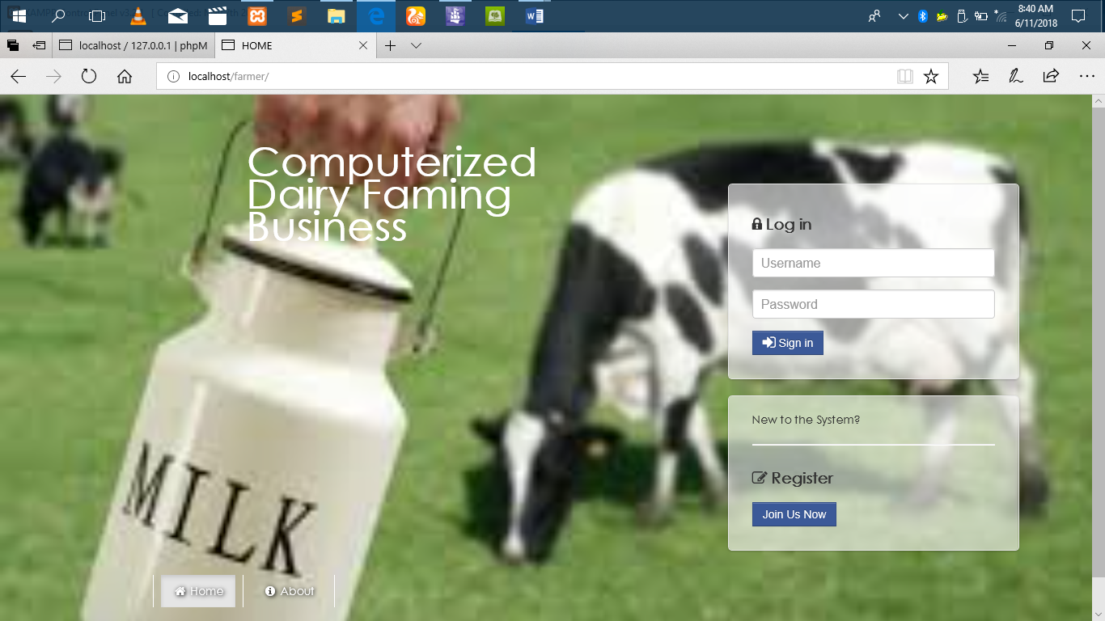

Figure 1 Home page

Here there is the name of the system which is; Computerized Dairy Farming Business. There is also the log in and registration site. An actor is supposed to register first in to the system inline with their involvement in the business. The registration page is as shown in figure (2) below;

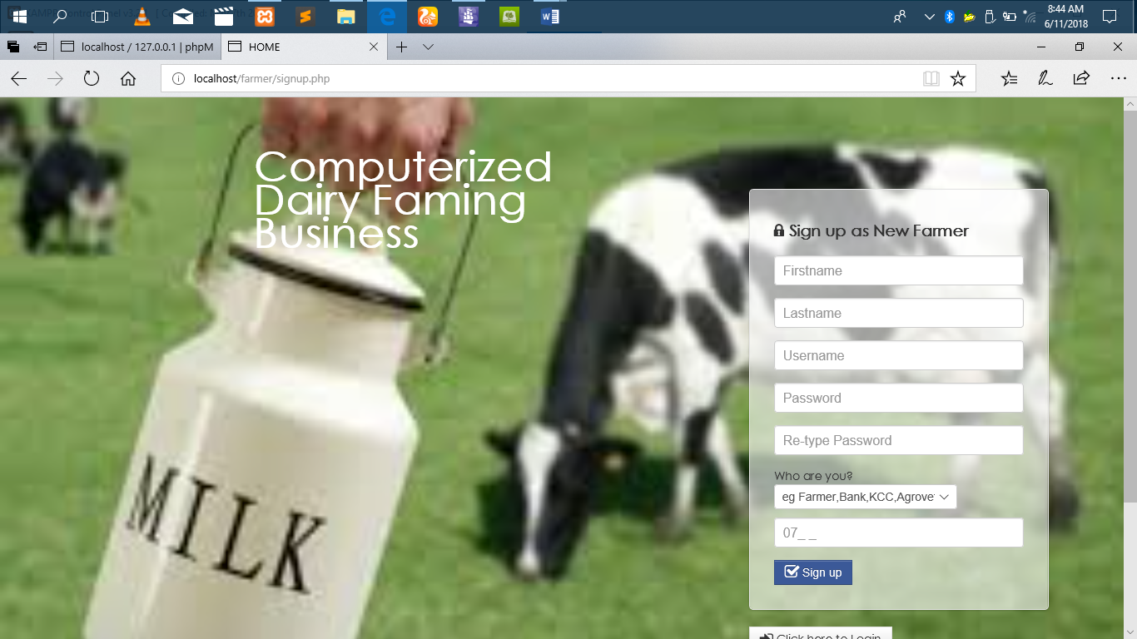

Figure 2 Registration Page

Here you are required to register into the system as new actor. You provide your firstname, lastname, username which is the email account, password to be using during logging in and then you retype your password for verification. Then you chose who you are in the system. If you sign in as a farmer you are only going to operate from the farmers platform in the system. Then you provide your contacts and sign in.

During logging in, you provide the username you registered with and you provide the password still used during registration.

## **4.4.1 When signed in as a farmer,;**

The following is the is the farmers page as shown in figure (3)

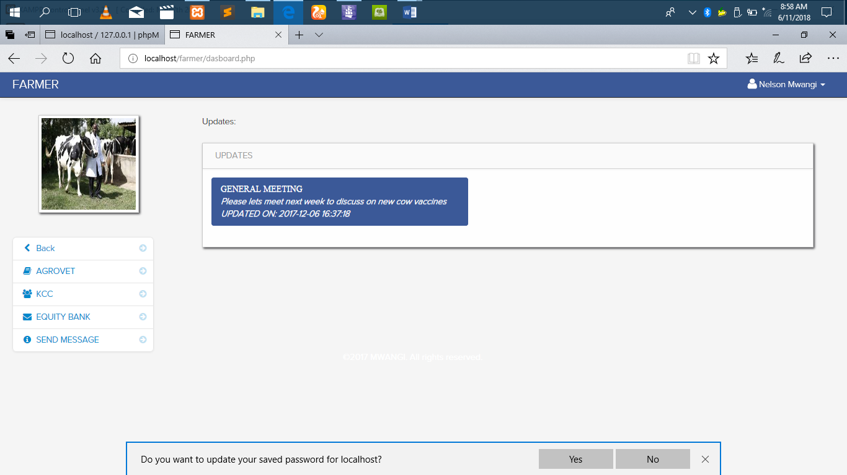

Figure 3 Farmer Page

.

The farmer can see updates and reply via sending a message. For example he can send a message to the agrovet. As shown in figure (4) below;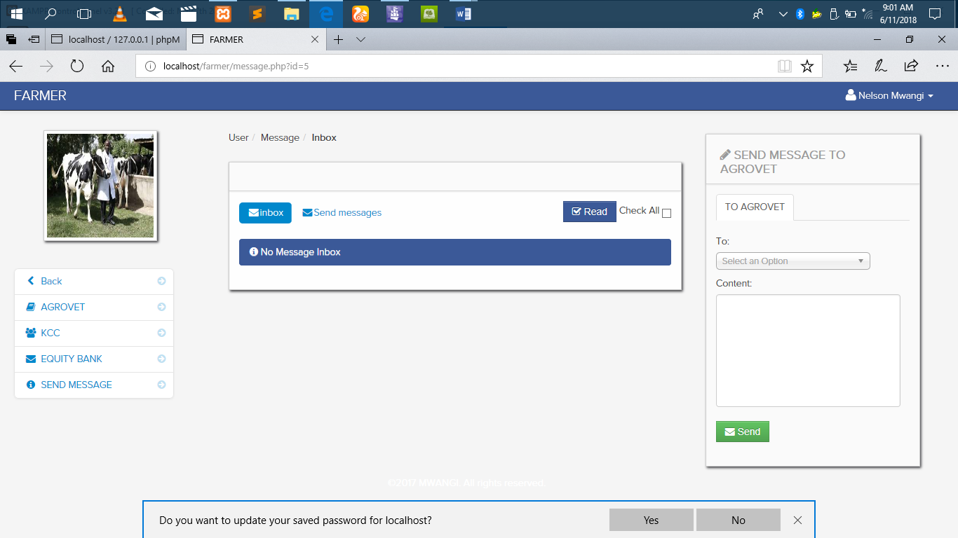

Figure 4 Message page

In the figure (5) below, it shows how the farmer may interact with the agrovet;

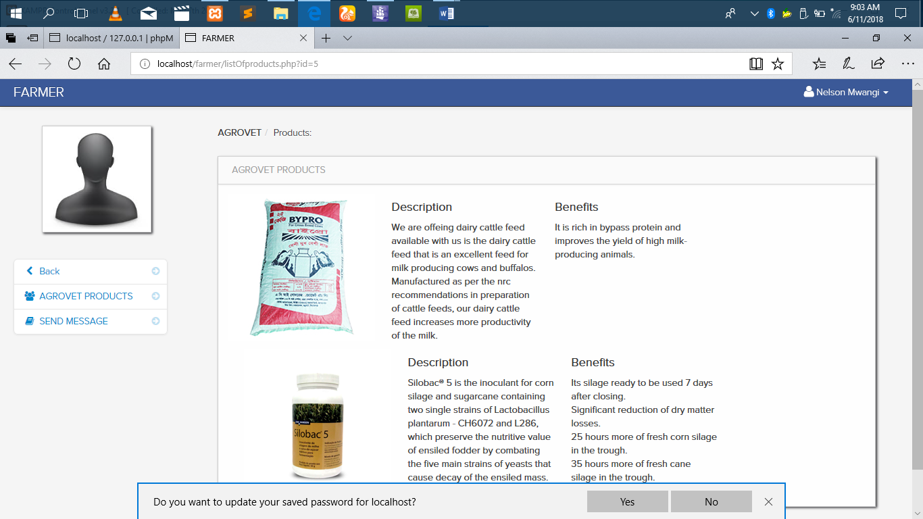

Figure 5 Agrovet products

The farmer is able to view the agrovet products and place an order of what he/she needs by simply sending a message.

The farmer also is able to interact with the KCC to view the milk rates, quantity sold, new updates and can send a message to the KCC as shown in figure (6) below.

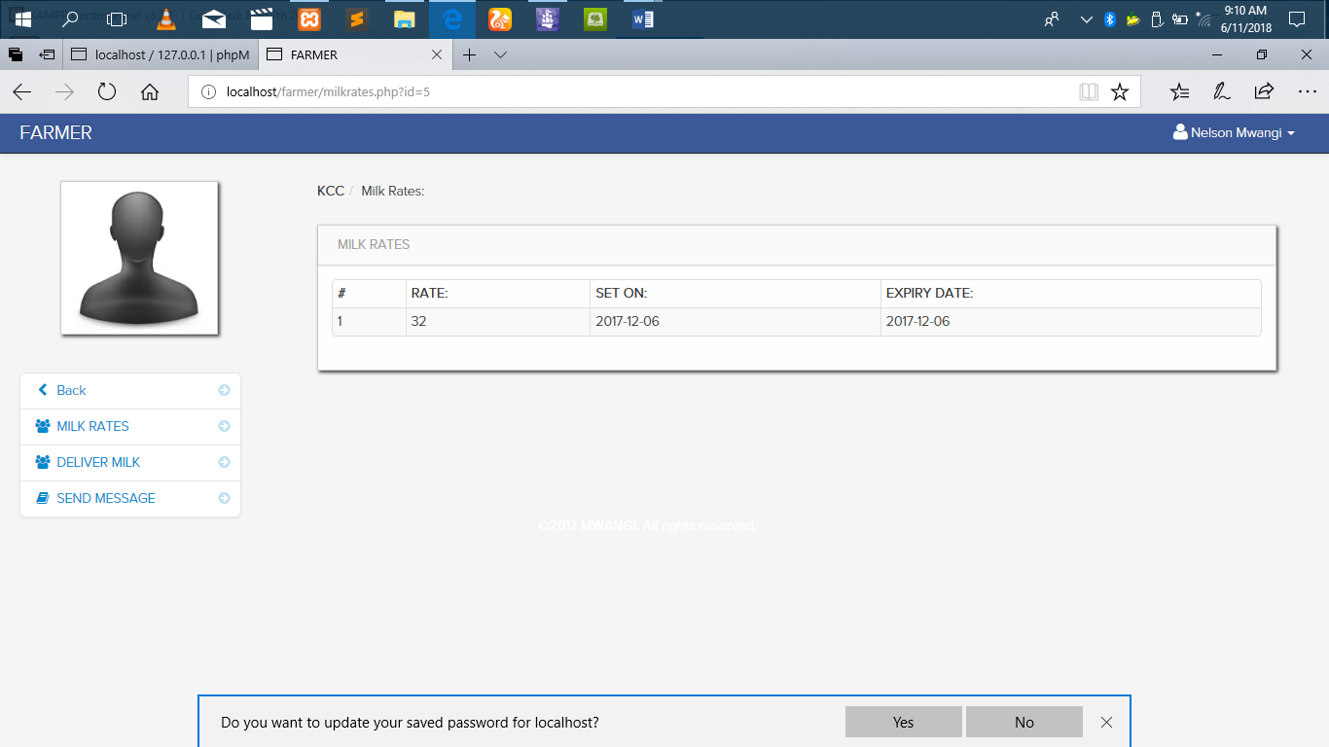

Figure 6 Farmers’ interaction with the KCC.

In the figures below, they show farmers interaction with the bank in the system.

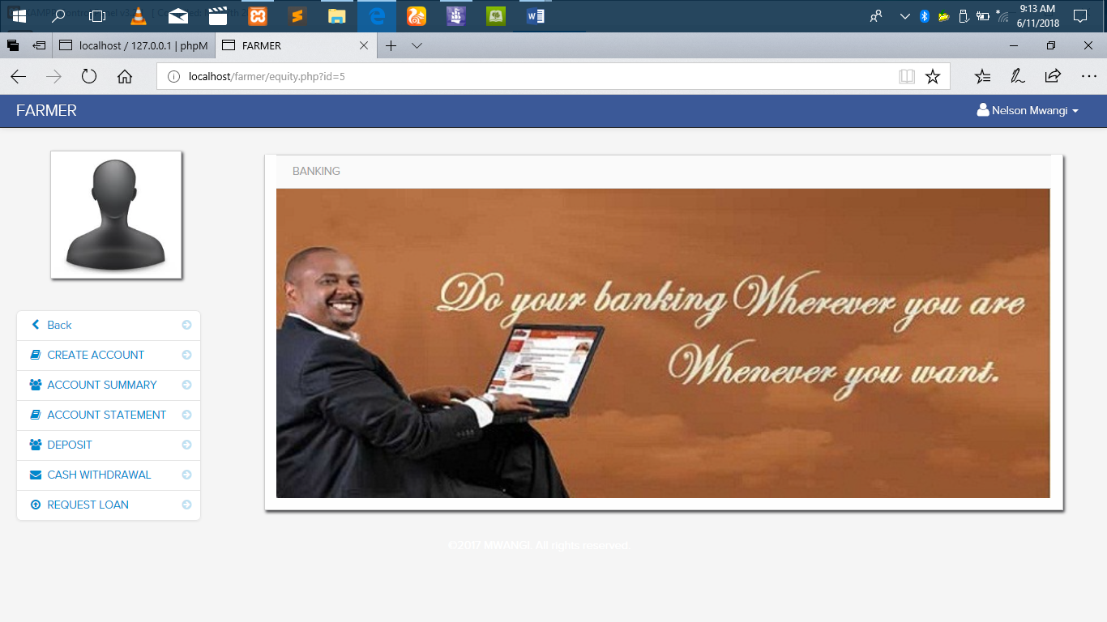

Figure 7 farmers’ interaction with the bank.

The farmer can open an account as shown in figure (8) below;

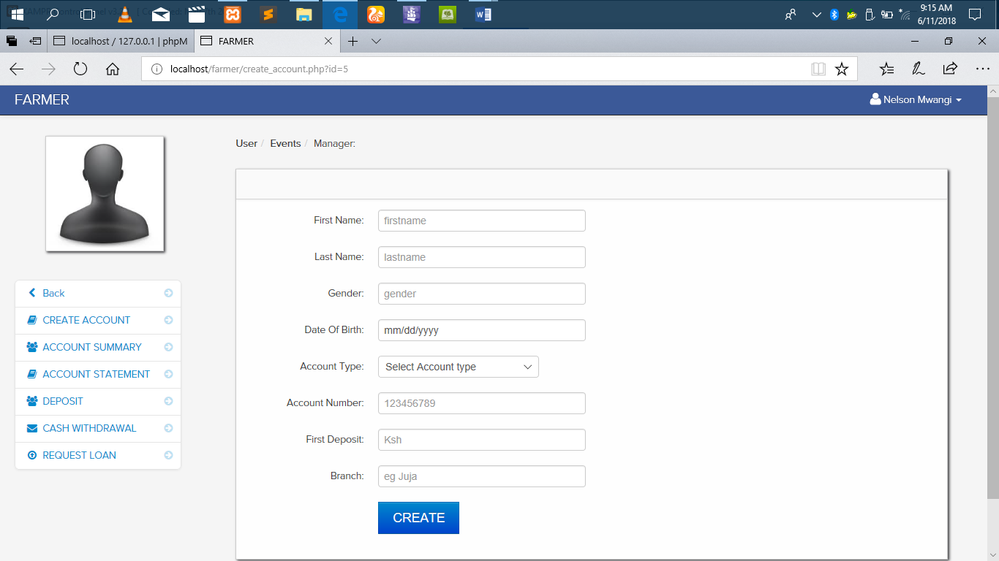

Figure 8 Farmers’ account creation in the bank.

The farmer is required to provide the details requested in the account creation site for him/her to create an account with the bank.

Figure (9) below show farmers account summery.

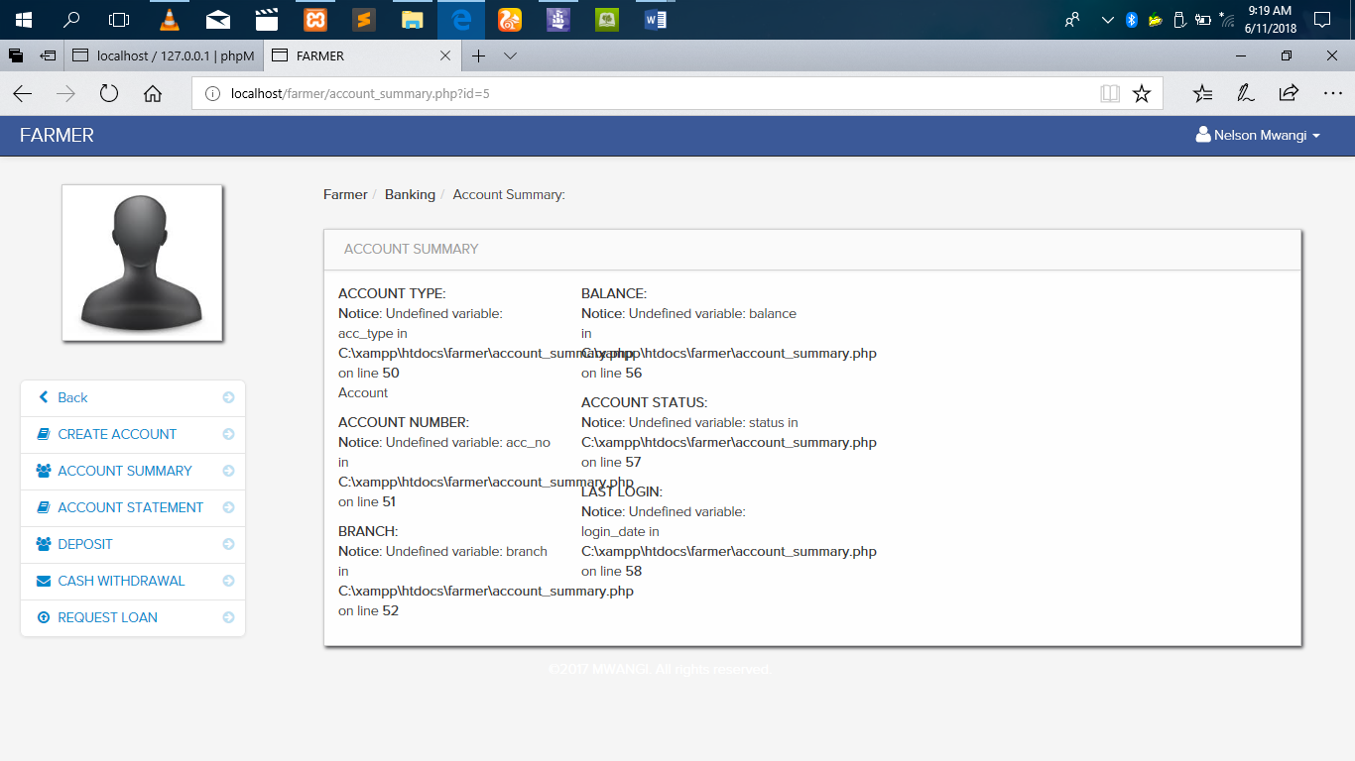

Figure 9 Farmers bank account summary.

Also the farmer can view their account statement in the bank in the site shown in figure (10) below;

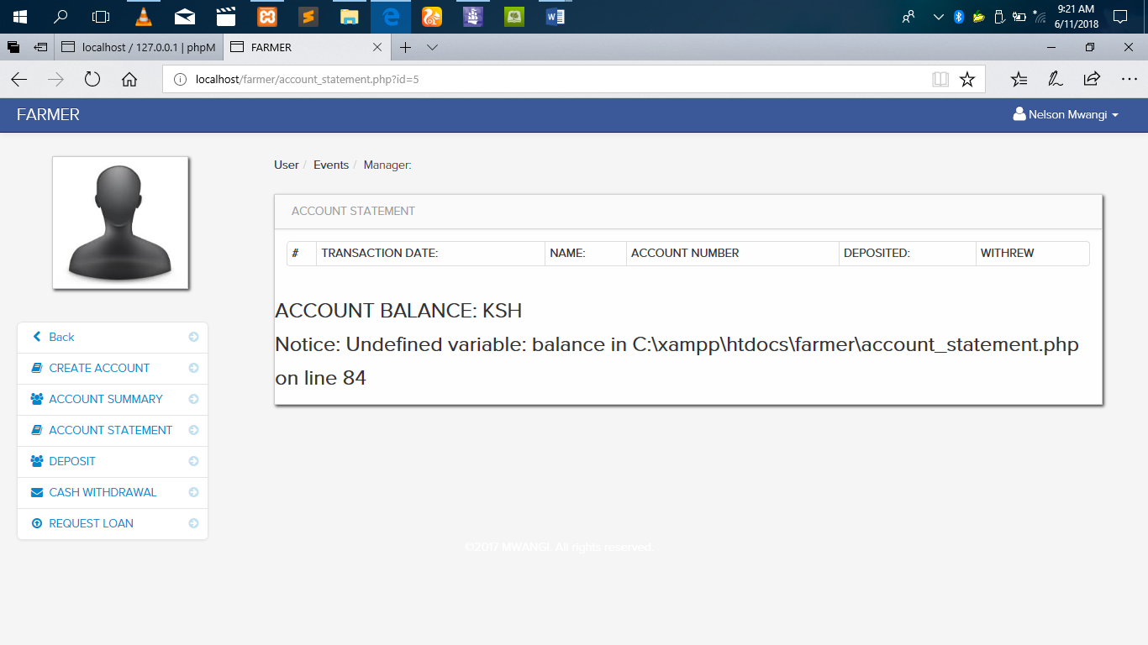

Figure 10 farmers’ bank account statement viewing.

In then figure (11) below, it shows how the farmer is to make deposit to the bank.

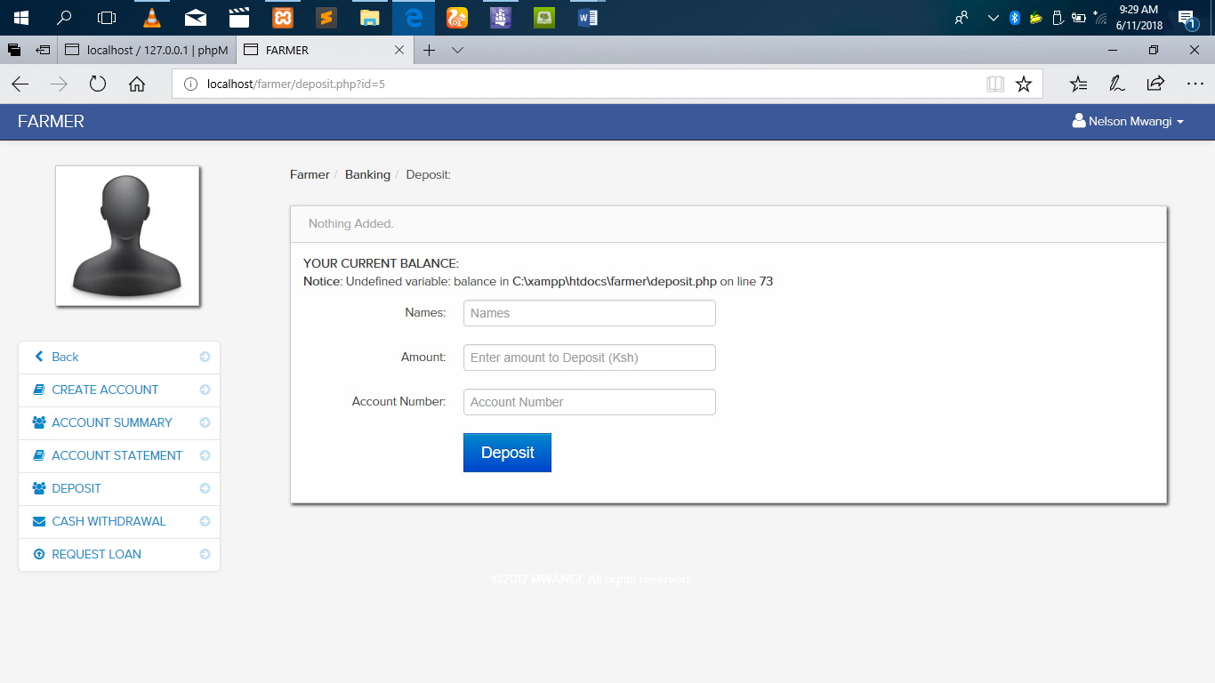

Figure 11 Farmer depositing in the bank.

Figure (12) shows how the farmer can withdraw from the bank.

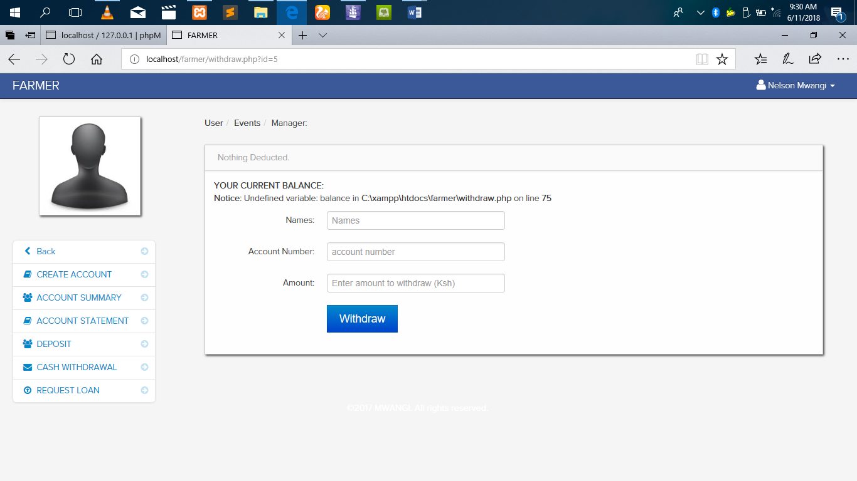

Figure 12 farmer withdrawing from the bank.

And finally the interaction of the farmer and bank for loan request. This is shown in figure (13) below.

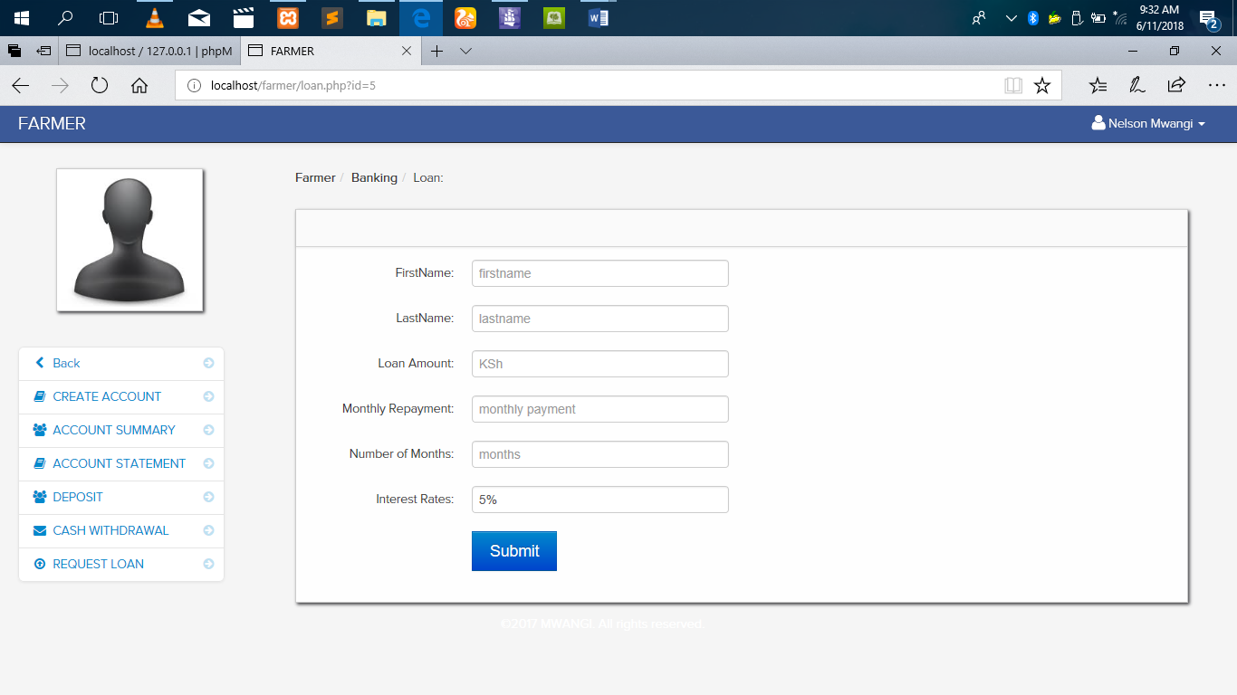

Figure 13 Farmers’ loan request site.

In addition, at the right corner at the top, its where one may log out, change averter or change their password.

### **4.4.2 When signed in as Bank;**

The following is the home page when one signs in as bank as shown in the figure (14) below.

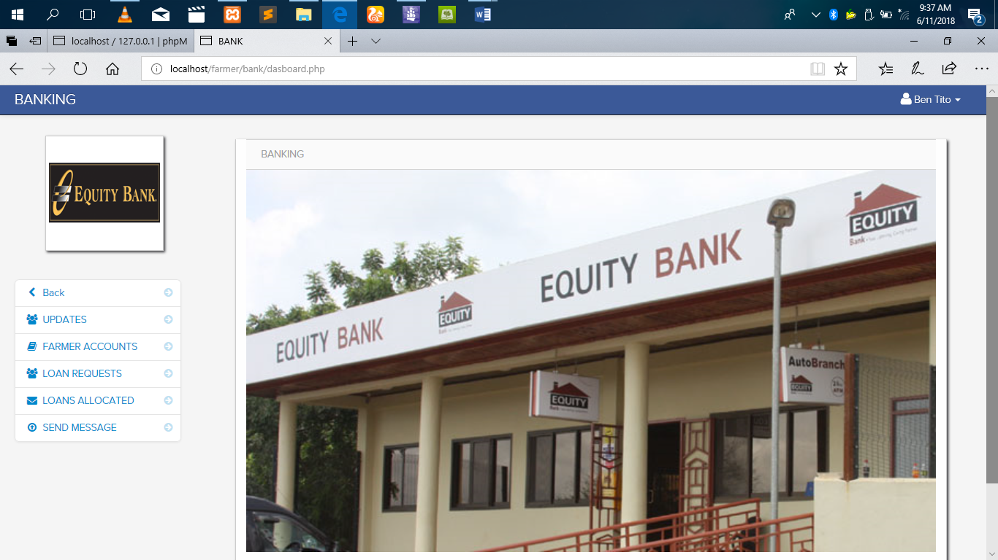

Figure 14 Bank home page.

When the bank signs in, they can be able to interact with the farmer in the forms shown in figures that follows.

The bank can view updates from the farmer as shown in figure (15) below.

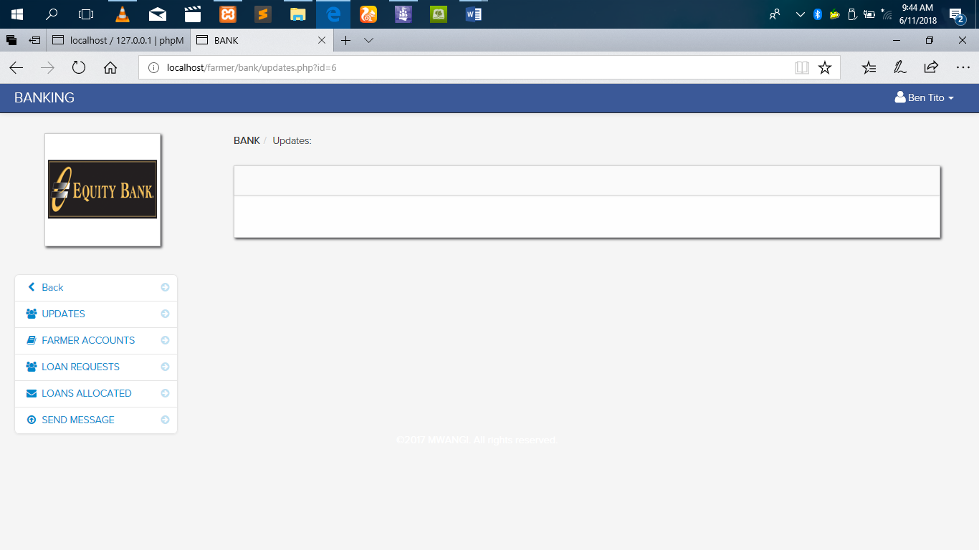

Figure 15 updates from the farmer to the bank.

Figure (16) below shows the farmers account in the bank.

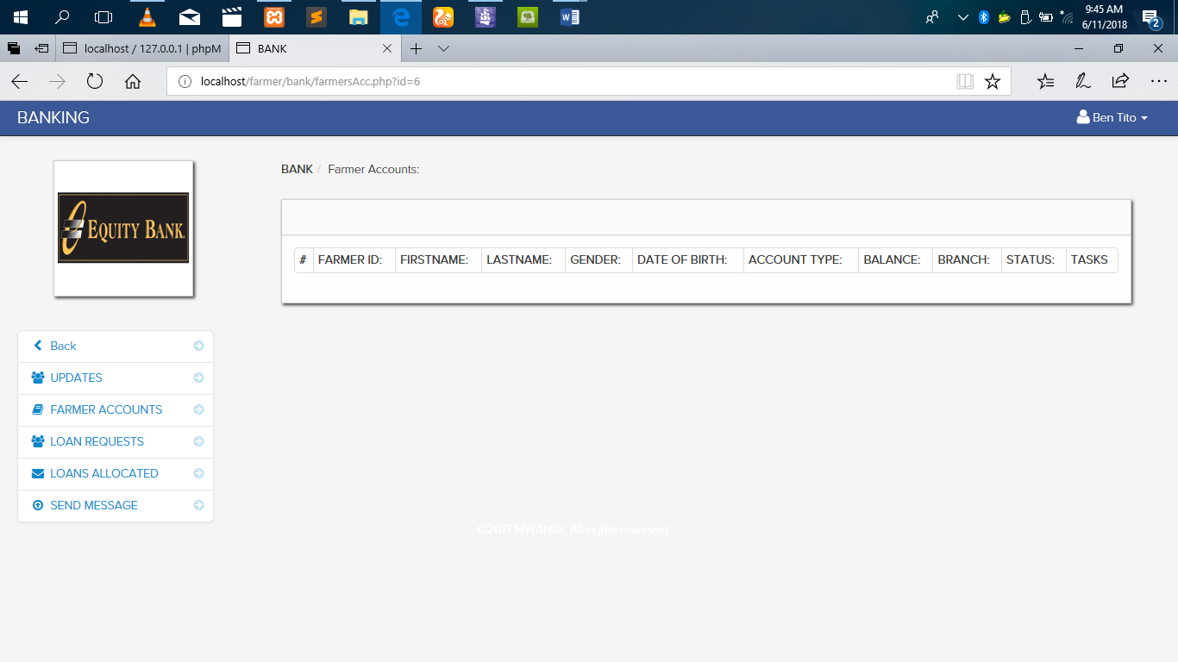

Figure 16 farmers account in the bank.

In figure (17) below; it shows the bank site on the loan requested by the farmer.

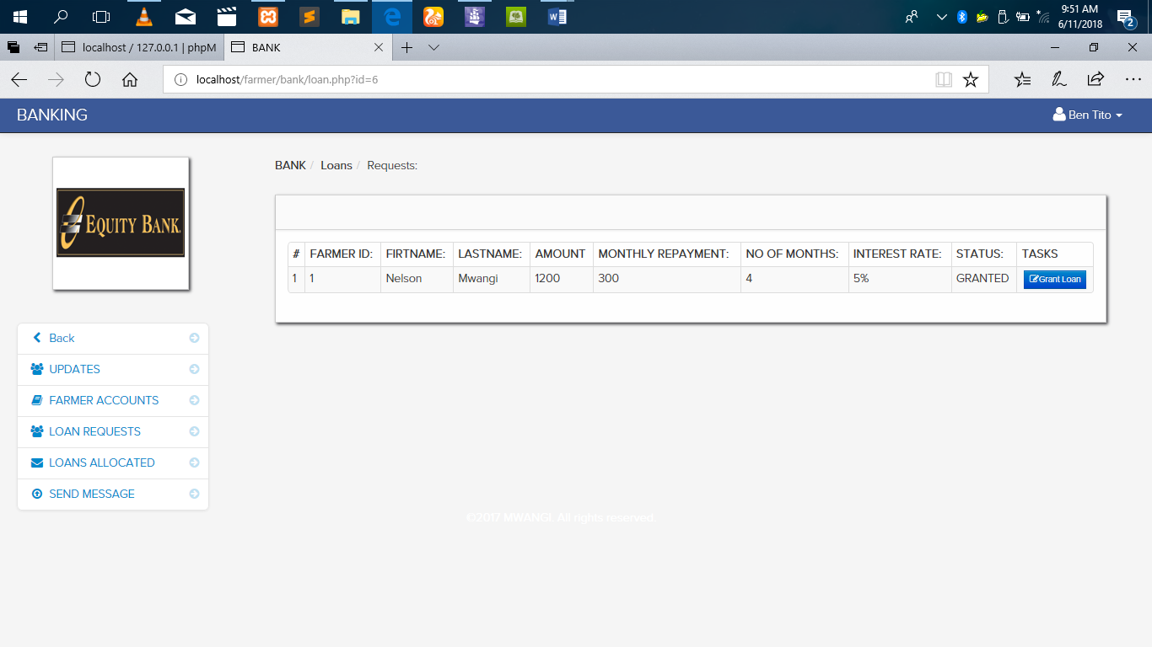

Figure 17 loan request.

In the figure (18) below shows how much loan is allocated to which farmer.

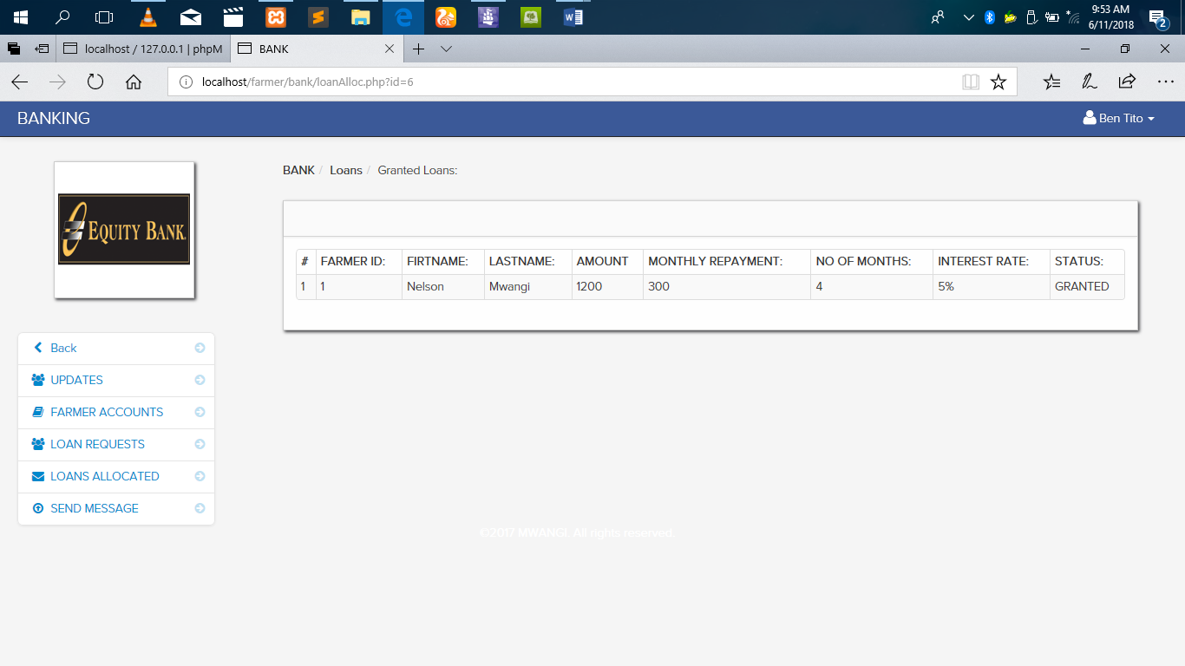

Figure 18 loan allocation to the farmer by the bank.

In the figure below (19) it shows how the bank can send a message to the farmer;

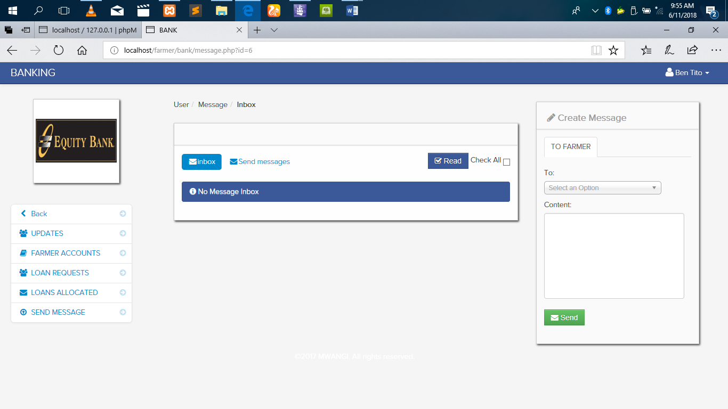

Figure 19 bank sending message to the farmer.

Then the bank may log out.

### **4.4.3 Signed in as KCC / Creameries.**

Figure (20) below shows the home page when one signs in as KCC.

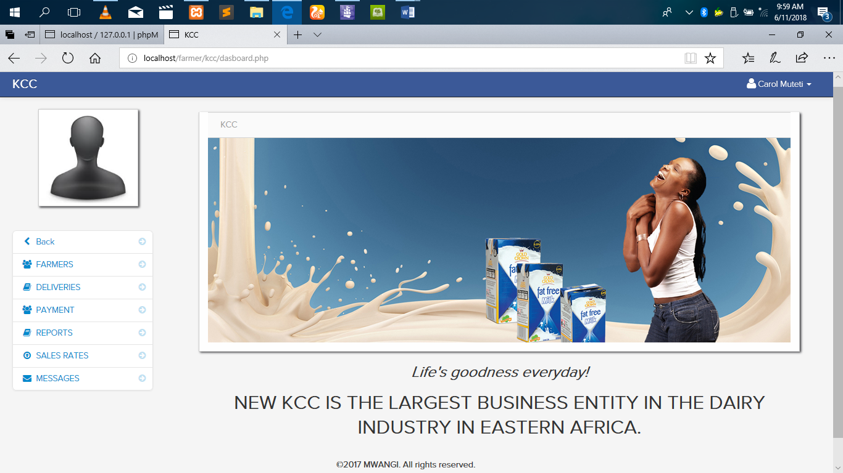

Figure 20 KCC home page.

Here the Creameries can interact with the farmer as shown in the figures that follows. In the figure (21) below, it shows how KCC may add a farmer in their list.

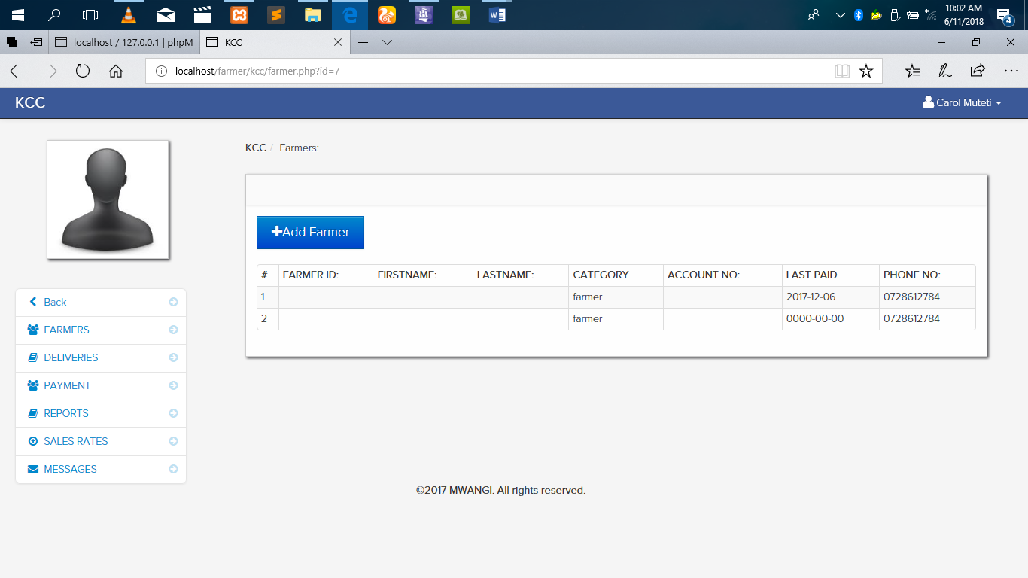

Figure 21 KCC adding a new farmer.

Figure (22) below shows KCC posting daily deliveries of farmers milk.

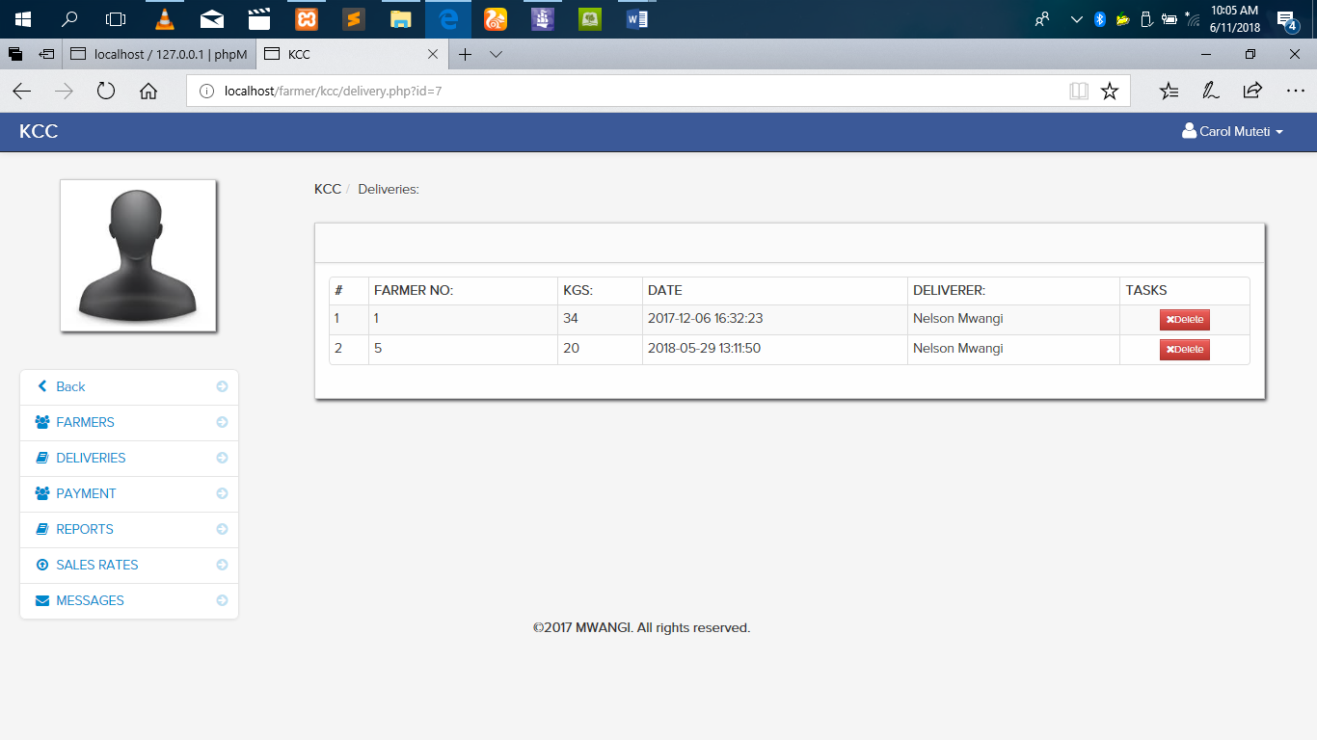

Figure 22 daily post of KCC of milk delivery.

Figure (23) below shows how payment is made by the KCC to the farmer for the milk sold.

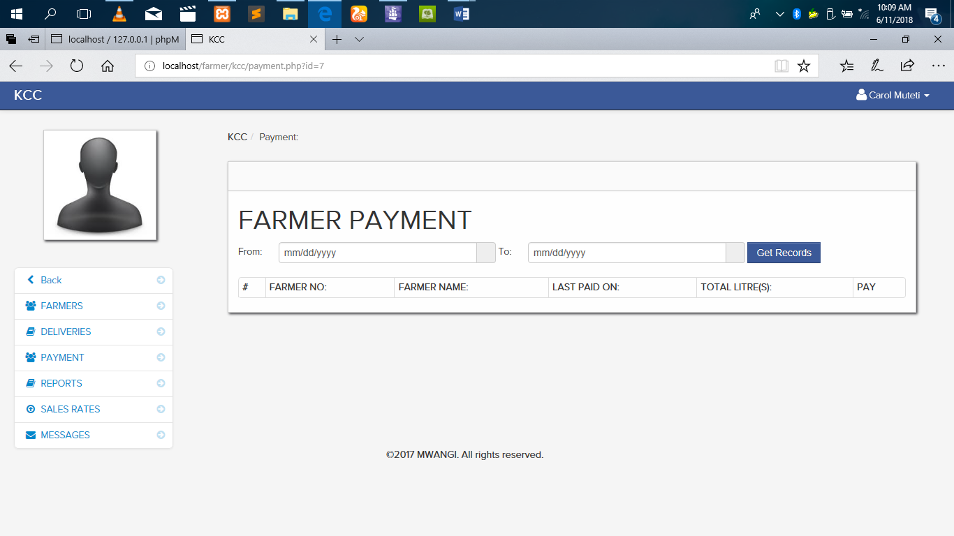

Figure 23 Farmers’ payment.

Figure (24) below shows the farmers supply report.

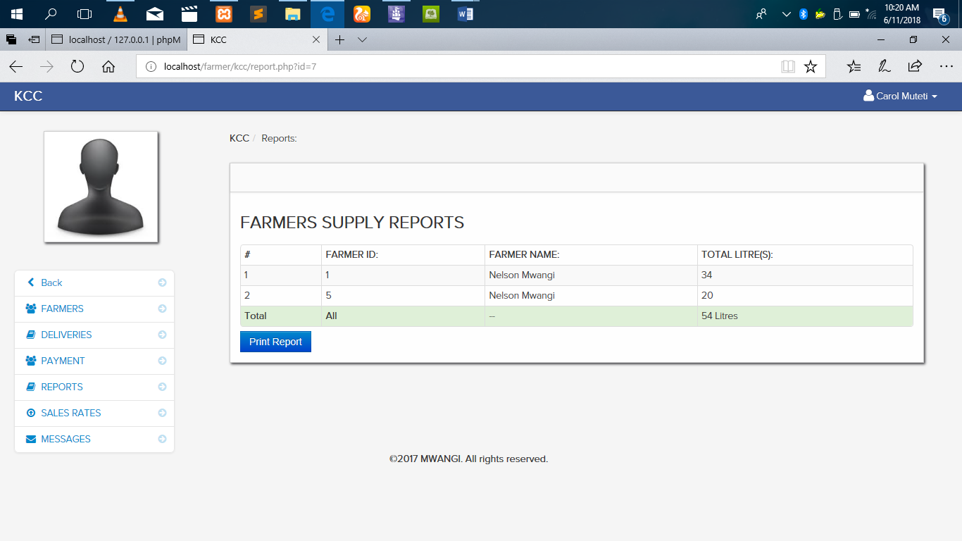

Figure 24 Farmers supply report.

Figure (25) below shows the daily rates of buying the milk from the farmer

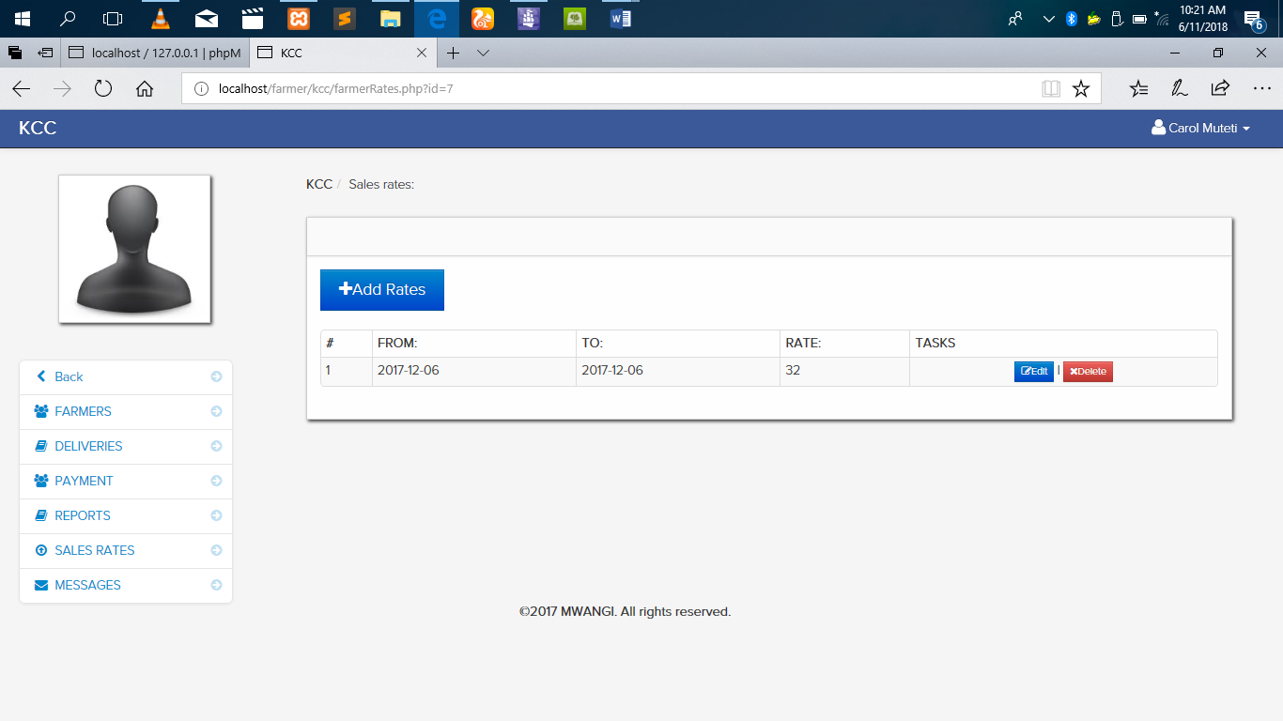

Figure 25 daily milk rate per litre.

And finally in figure (26) below, it shows how the KCC can send a message to the farmers.

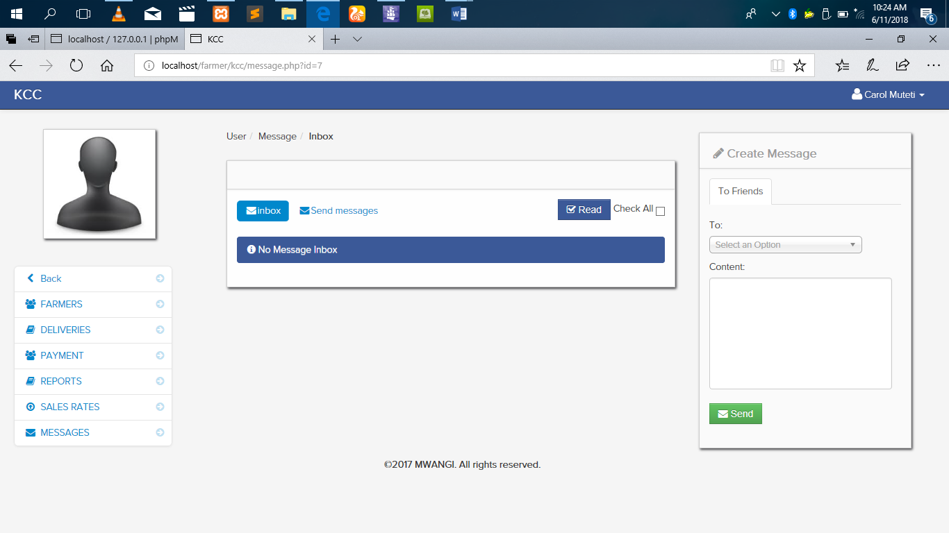

Figure 26 send message to farmers.

And the KCC can also log out.

### **4.4.4 Signing in as an agrovet.**

This is the fourth actor in the system. When one signs in as an actor, the following in figure (27) is the home page.

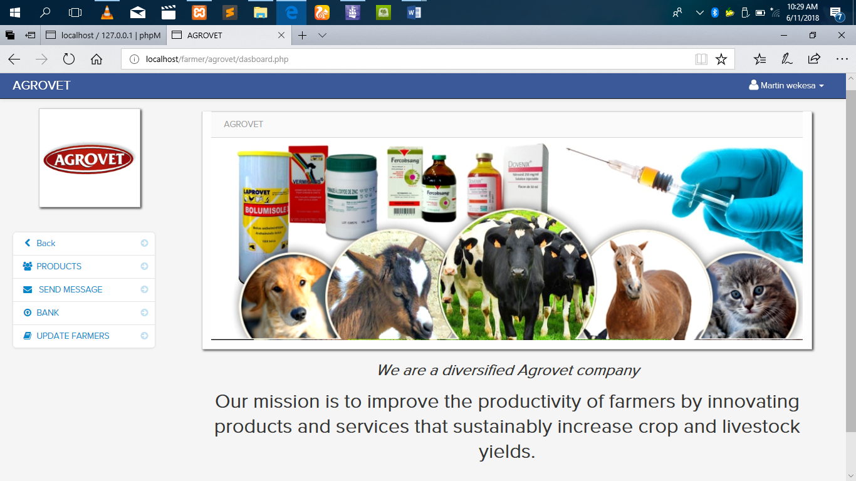

Figure 27 Agrovet home page.

Here the agrovet can post the products they are selling as shown in figure (28) below.

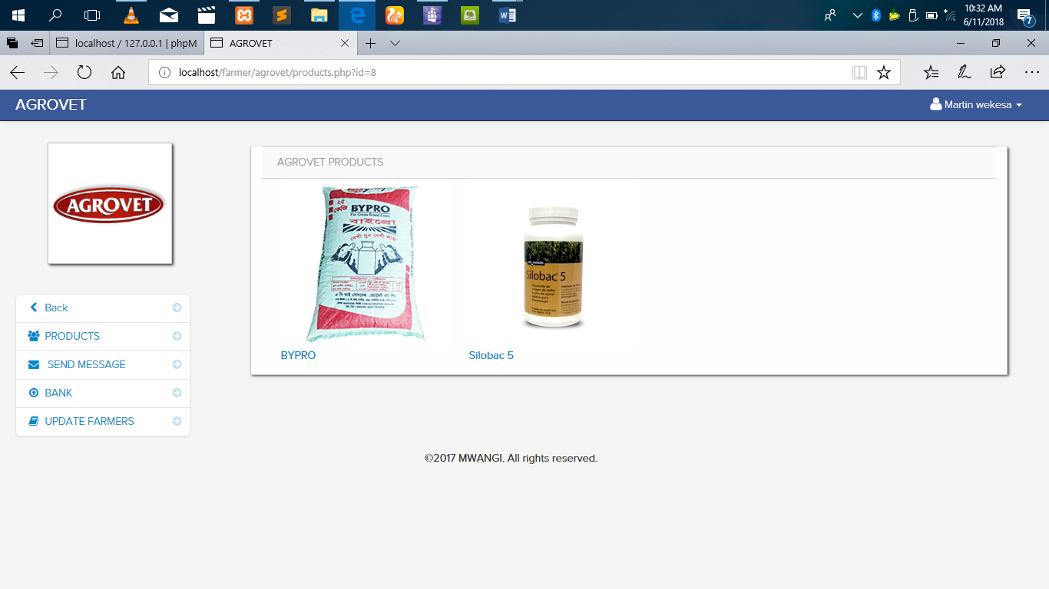

Figure 28 Agrovet Products.

Figure (29) below shows how te agrovet may send a message back to the farmer in reply of the farmers message.

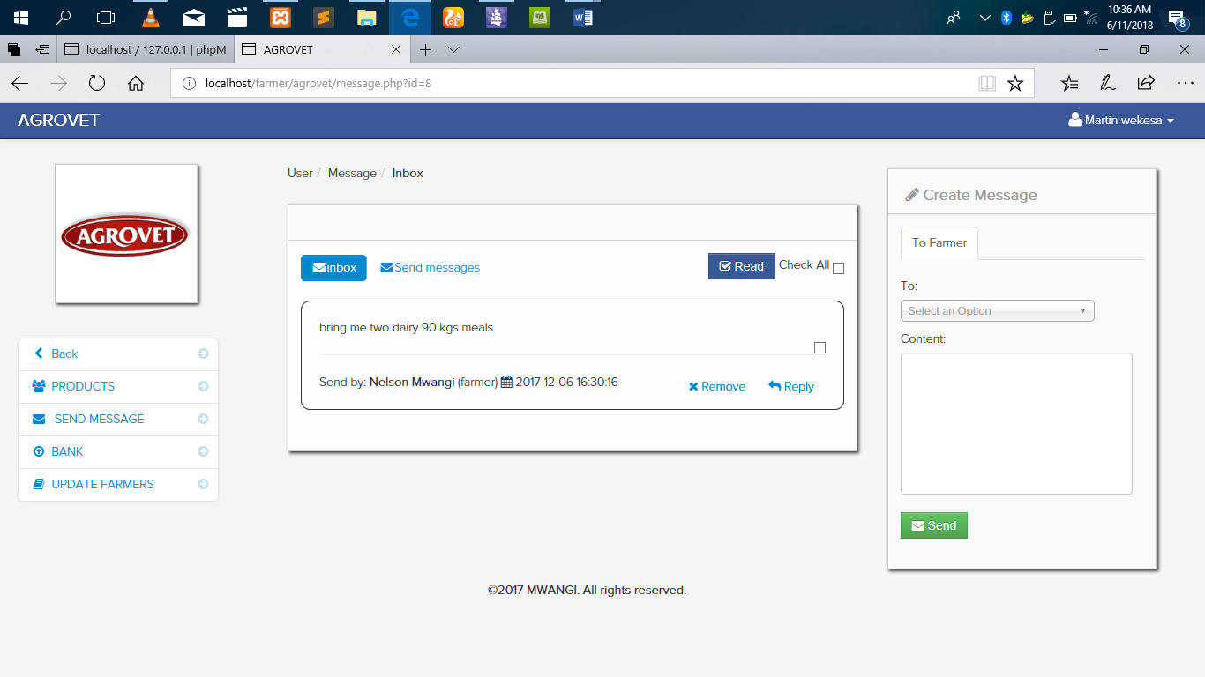

Figure 29 Agrovet reply.

Figure (30) below shows the interaction of the agrovet with the bank for payments of products ordered by the farmer.

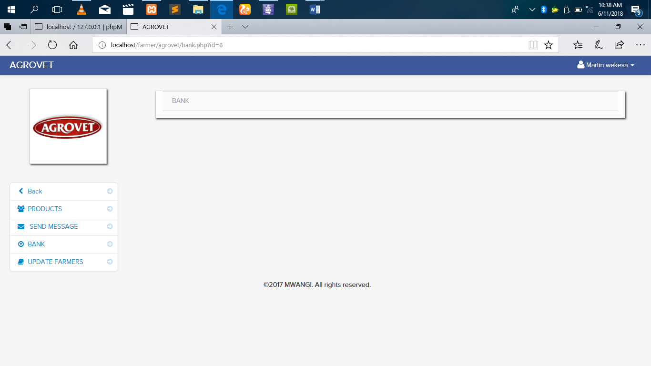

Figure 30 bank paying the agrovet.

Figure (31) below shows the agrovet sending update to the farmer of new developments or new information.

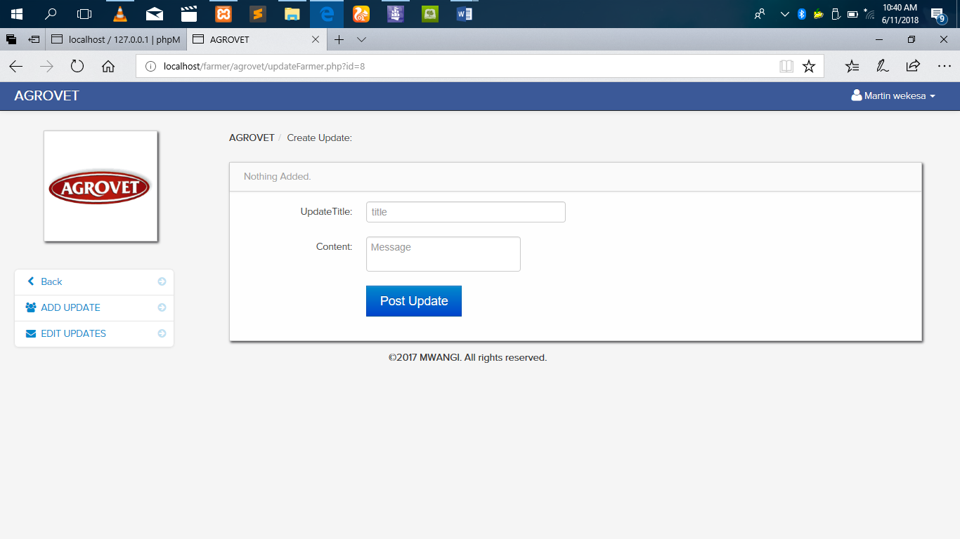

Figure 31 Agrovet updates o the farmer.

# **CHAPTER 5.**

# **5.0 SUMMARY OF FINDINGS, CONCLUSION AND**

# **RECOMMENDATIONS OF FINDINGS.**

## **5.1 Introduction.**

This project sought to develop a computerized dairy farming management system for the dairy business players of Nyandarua south district of Nyandarua county. It therefore contains a summary of findings discusses these findings and furnishes conclusions based on the objectives of the research study. The chapter also contains some recommendations for consideration based on the study findings. The tail end section deliberates on the contributions of the study to the general body of knowledge.

## **5.2 Summary of the Findings**

The first objective of the project was to create a platform that will interlink the farmer, bank, kcc and an agrovet store for cohesion of operations in the dairy business. The most fundamental area is the level of education which helps in creating interpersonal relationship which is extended to electronic. The level of education I found out that most of the respondents are undergraduate degree holders who chose dairy farming business as their career path. Because the system will rely on the use of computers, majority of the respondents have computer machines and have internet connections because the government have developed the infrastructure. There is electric power and communication service providers such as safaricom and airtel have availed their services even into the villages.

The second objective in the development of the project was to develop a system that will enhance on time communication and information management and sharing among the dairy farming business players. The results showed that male seem to dominate in the venture of dairy business having the highest population of youths who age between 18 years and 39 years. Most of the respondents profession is farming and most of them have been in the dairy business industry for more than two years. Another very vital finding was that most of the respondents especially farmers take more than 1 hour for them to access a financial institution like a bank and an agrovet shop or store.

The third and final objective in the development of the project was to generate a fast, accountable and flexible mode of resources transaction among the dairy business players. i.e coming up with a way of money movement form one person to another with very less cost and in a manner that it can be accounted for. The findings showed that average respondents know about the electronic money transaction but they have to travel for them to carry out transactions. Where else another finding indicated that most farmers earn between ksh 20,000 and ksh 40,000, this is a prove that dairy business farming is a rewarding course of career. Lastly is that most respondents were averagely agreeing that the system wont be hard to use since most of them are undergraduate people.

## **5.3 Conclusion.**

Whereas major strides have been made, there is still a lot of room for improvement as far as the dairy sector goes. The concept of dairy farming, and commercialized agriculture as a whole, is yet to be fully sold to the youthful populace in Kenya. The levels of Government support in terms of trainings and other capacity building exercises, provision of extension services and raising awareness levels in dairy farming as far as e-commerce, telecommunication and management are concerned and other best practices go was deemed to be wanting. Though mechanization is possible, it has been established from this project that dairy farming particularly in Kenya is a largely job and wealth creating ground and it calls for a certain level of attention and commitment from the four players. It has also been established that whereas the age factor, levels of education and awareness and practical experience in airy farming were pertinent to improved dairy farming, the variability of good interconnection and cohesion of operations, fast and flexible mode of resources transaction and efficient communication and information sharing and storage for better decision making among the players was seen to be the most fundamental determinant of dairy farming business smooth flow and growth leading to business size expansion and increased profits.

## **5.4 Recommendation.**

Having looked at the theoretical framework, the conceptual framework, alongside the literature review, the study findings and the conclusions made, a series of recommendations are pointed out:-

That the Government of Kenya, through the relevant Ministry and State Departments, join hands with key stakeholders in the private sector to undertake a nationwide campaign to promote commercial dairy farming, and more so promote the stocking of quality dairy feeds by agrovet stores and through easily accessible financial arrangements. Also the government to ensure there is more agrovet officers who will reach out to the farmer as quick as possible if need be. Proper utilization of land to ensure its maximum utility is realized, among other dairy farming best practices, should be inculcated to the farmers as well as would be dairy farmers in order to ensure there is a sustained consistency in the improvement of milk production. Also efforts should be made to reach more female farmers through developing gender sensitive extension packages and extension approaches that are gender friendly. This is to try and encourage more female to take frontline in dairy farming and increase the current production in dairy sector.

**References.**

Brookside Dairy Limited Website: http://www.brookside.co.ke/bc about.html retrieved April 2013. Githunguri Dairy Farmers Cooperative website: http://www.fresha.co.ke/aboutus/githunguri-dairy-farmers-cooperative/ retrieved April 2013.

East Africa Dairy Development Program ( 2008): The Dairy Value Chain in Kenya

.A report by Techno Serve Kenya Food and Agricultural Organization (2010) A Summary of Milk Production across the World GoK. (2011). District Livestock

Production Imenti South District, Annual Report. Unpublished Report.

(2010): Kenya national dairy master plan Ministry of Livestock Development .Government printer, Nairobi, Kenya.

(2009) Agricultural sector development strategy (ASDS) 2009 – 2020.Government printer, Nairobi, Kenya.

(2008): Ministry of Livestock Development Sessional Paper No.2 of 2008 on National livestock policy. Government printer, Nairobi, Kenya

Hagg blade, S. (2011),"Modernizing African Agribusiness: Reflections for the Future", Journal of Agribusiness in Developing and Emerging Economies, Vol. 1 Iss: 1 pp. 10 – 30

Karanja A.M .(2003). The Dairy Industry in Kenya: The Post Liberalization Agenda. Unpublished Reort.

Njubi, D. M., Wakhungu, J. and Badamana, M.S. 2009a. Mating decision support system using computer neural network model in Kenyan Holstein-Friesian dairy cattle. Livestock Research for Rural Development 21 (4).

Njubi, D.M., Wakhungu, J. and Badamana, M.S. 2009b. Milk yield prediction in Kenyan HolsteinFriesian cattle using computer neural networks system. Livestock Research for Rural Development 21 (4).

Nuthall, P. L. 2003. Case studies of the interactions between farm profitability and the use of a farm computer. Computers and Electronics in Agriculture 42(1) 19-30.

<https://sites.google.com/site/ignoubcafinalyearprojects/project-report/dairy-management-system-project-repor>

Okello, Duncan and M.J. Gitau. (2006). Readings on Inequality in Kenya: Sectoral Dynamics and Perspectives. Society for International Development, Nairobi.

Thompson, Jill. (2008). The Kupfuma Ishungu Rural Finance Project, Zimbabwe. SEEP Network, Washington.

Mylenko, Nataliya et. al. (2009). Financial Access, 2009: Measuring Access to Financial Services around the World. CGAP, Washington.

https://blog.equinix.com/blog/2017/07/24/what-is-interconnection-what-companies-need-to- know-about-interconnection-to-succeed-at-digital-business/

Donner, J. & Tellez, C. (2008). Mobile Banking and Economic Development: Linking Adoption, Impact and Use‖. Asian Journal of Communication, 318-322.

http://erepository.uonbi.ac.ke/bitstream/handle/11295/55860/Abstract.pdf?sequence=3

http://erepository.uonbi.ac.ke/bitstream/handle/11295/103029/Bii_Factors%20Influencing%20Performance%20of%20Dairy%20Farming%20Projects%20in%20Cherangani%20Sub%20County%2c%20Trans-nzoia%20County%2c%20Kenya.pdf?sequence=1&isAllowed=y

<http://shodh.inflibnet.ac.in/bitstream/123456789/57/4/04_chapter%202.pdf>

TechnoServe (2008). The dairy value chain in Kenya.Project report for the East Africa Dairy Development Program.

Theron H.E & Mostert B.E (2008). comparison of production and breeding potential of South African dairy herds on different feeding systems. Nat. Milk Rec. Improv. Scheme Newsletter 13, 26-29.

# APPENDICES

# APPENDIX A: QUESTTIONNAIRE

Part 1

This questionnaire is on assessment of a comparative project of developing a computerized dairy farming management system for the dairy farmers’ of Nyandarua south district in Nyandarua County. The exercise is in line with project study requirement in partial fulfillment of a bachelors degree of business information technology at Jomo Kenyatta University of Agriculture and Technology. The data collected will be used for said purpose only. The identity will be held with strictest confidence. Kindly respond to all questions by indicating by ticking the space provided or by explaining your opinion briefly on the space provided. Please respond to all the questions accurately and honestly.

Part 2.

Objective 1. To create a platform that will interlink the farmer, bank, milk company and an agro-vet shop for cohesion in operations involved in the dairy business.

1. What is your highest level of education.
2. Secondary ( )
3. Certificate ( )
4. Diploma ( )
5. Undergraduate degree ( )
6. Postgraduate degree ( )
7. Other (please specify) ( )
8. Do you know how to use a computer?

Yes No

1. Do you have internet connection?

Yes No

Part 3.

Objective 2. To develop a system that will enable on time information management and sharing among the four players.

1. Age
2. Between 18 and 29 years ( )
3. Between 30 and 39 years ( )
4. Between 40 and 49 years ( )
5. Between 50 and 59 years ( )
6. Above 59 years ( )
7. Gender

Male ( ) Female ( )

1. Please state your profession

……………………………………………………………………………………………

1. How long have you been in dairy business?
2. 6 months ( )
3. Up to 1 year ( )
4. Up to 1 and half years ( )
5. Uo to 2 years ( )
6. How long does it take you to access the nearest bank or agrovet from your place of residence?
7. Less than 30 minutes ( )
8. Less than 1 hour ( )
9. More than 1 hour ( )
10. Do you use texting as a mode of communication?

Yes ( ) No ( )

Part 4

Objective 3. To generate a fast, flexible and. accountable mode of money transaction among the dairy business players.

1. Do you use electronic money transacting methods with your operations?

Yes ( ) No ( )

1. Please select your monthly income level (Ksh).
2. Below 20,000 ( )
3. Between 20,000 and 40,000 ( )
4. Between 41,000 and 60,000 ( )
5. Between 61,000 and 80,000 ( )
6. Above 80,000 ( )
7. What is your statement on perceived Ease of use of the computerized dairy farming management system?

|  |  |  |  |  |  |  |
| --- | --- | --- | --- | --- | --- | --- |
| Item | Statement | 1.(SD) | 2.(D) | 3.(NS) | 4.(A) | 5.(SA) |
| i. | Learning to use the system would be easy |  |  |  |  |  |
| ii. | Interacting with the system won’t require a lot of mental effort |  |  |  |  |  |
| iii. | It will be easy to use system to accomplish my tasks |  |  |  |  |  |
| iv. | Using system does not require training |  |  |  |  |  |

1-Strongly Disagree (SD); 2-Disagree (D); 3-Not Sure (NS) 4-Agree (A); 5-Trongly Agree (A)

# APPENDIX B: COST AND MATERIAL ESTIMATES

|  |  |  |  |  |  |
| --- | --- | --- | --- | --- | --- |
| **S. No.** | **Items** | **Specifications** | **Quantity** | **@ Kshs** | **Amount, Kshs** |
|  | Printing paper | A4, high quality | 700 pages | 3 | 2,100 |
|  | Writing pad | A4, high quality | 7 | 50 | 350 |
|  | Transport |  |  |  | 5,000 |
|  | Equipment |  |  |  | 10,000 |
|  | Subsistence |  | 18 days | 1,000 | 18,000 |
|  |  |  |  |  |  |
|  |  |  |  |  |  |
|  | **Total** |  |  |  | **35,450** |